The Announcement
International Brotherhood Conference 2012
September 27th – 2nd October 2012
The Oceanic Library , Ashok Nilay Complex,
Ullon, Lakshmikantapur, 24 Parganas (South),
West Bengal, India. Pin : 743336
It is a matter of great pleasure to announce that an International Brotherhood Conference (IBC 2012) is being organized by Vivekananda Sevakendra –O- Sishu Uddyan (VSSU)w.e.f 27th September to 2nd October'2012 at Ashok Nilay Complex, Lakshmikantapur, South 24 Pgs., West Bengal, India, to mark the 150th birth anniversary of Swami Vivekananda which also coincides with the completion of 25 years of functioning of VSSU. The IBC-2012 would striving its best to ensure the august presence of distinguished visitors, representatives from the United Nations, International & Multilateral Funding Agencies, and Religious Institutions working to the cause of alleviation of human suffering, NGOs/Civil Society Members, and other dignitaries from about 50 different countries in the world.
Broad objectives of IBC 2012
The broad objective of this endeavor is to enhance humanity awakening, solidarity, goodwill, peace, communal harmony and youth leadership through the teaching of Swami Vivekananda.
Issues to be discussed in IBC 2012
The thematic centrality of the IBC-2012 will be governed by the principles of teachings of Swami Vivekananda in the area of love, humanity, peace & unity in diversity. The IBC-2012 will encompass all essential elements of an international conference starting from an inaugural ceremony marked by introductory remarks by some of the distinguished personalities of International repute along with flag hoisting, exhibitions, cultural events, seminars on diversified topics such as Millennium Development Goals (MDGs) of UN, socio-economic development, sustainable living & the likes.
The rationale of holding IBC 2012 in rural surrounding
It is satisfying to observe, that during the last 25 years VSSU has put forth its earnest effort in carrying forward sustainable community development projects through community resources, to generate self-employment and to enhance the dignity of rural population, burdened with extreme poverty. VSSU has been invited to grace seminars and meetings to more than 20 countries, spread in 4 continents in order to enunciate its vision, mission and practices on community development, through community resources to alleviate poverty. To complement the visits, VSSU also played host of interns from 39 countries spread in 5 continents. It is not an ignorable piece of information, to note that VSSU’s responsibility towards society has been much enlarged when the Economic and Social Council (ECOSOC) of the United Nations - last February, 2011, bestowed VSSU with the Special Consultative Status. Such accreditation, always works as a boost to a NGO, in order to contribute in the global arena. In this auspicious year, VSSU extends its heartfelt gratitude by requesting your gracious presence to celebrate the 150th birth anniversary of Swami Vivekananda and the celebration of 25 years of VSSU foundation as well, in the village of Ullon amidst the rural of India –whose sweat & toil have enriched the land for generations.
IBC 2012 as 3 in 1 Conclave
By commemorating and practicing the principles and teachings of Swami Vivekananda, VSSU believes, it would be able to achieve holistic understanding of every problem, that men suffers in this mundane world. In this connection, the IBC-2012 comprising of "three Conferences in one", would concentrate on three core aspects viz. (i) Attainment of Millennium Development Goals (MDGs) in the backdrop of the philosophy of Swami Vivekananda. (ii) Peace, Communal Harmony & National Integration & (iii) Global Cultural confluence. Parallel sessions concomitant to these aspects would predominantly focus on underlying intricacies and modus operandi. These three strands would be brought together into exciting plenary sessions and debates that would be of commoners' concern. Such organizational efficacy would, in turn, ensure that the IBC'2012 be of worth for a wide cross-section of participants as, local community, policy makers, international representatives, NGOs, academicians, volunteers and so forth.

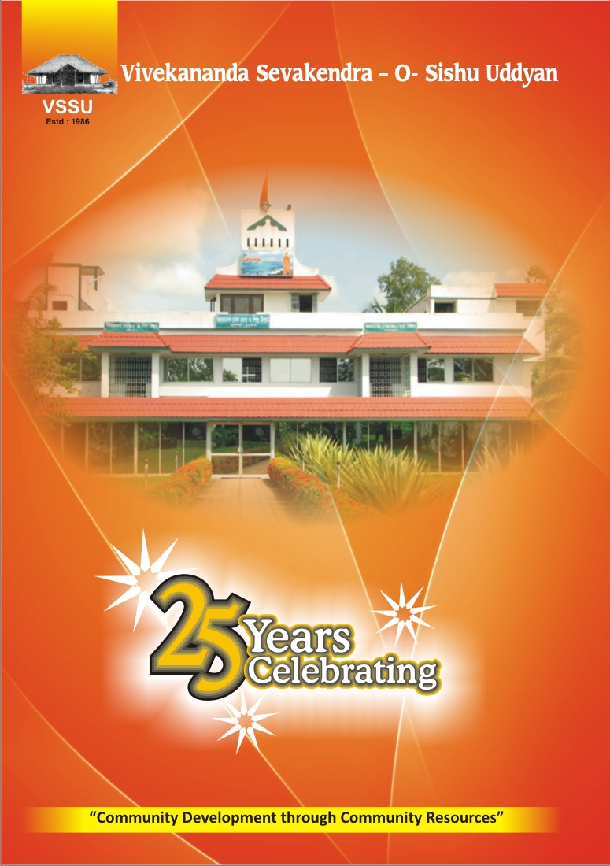
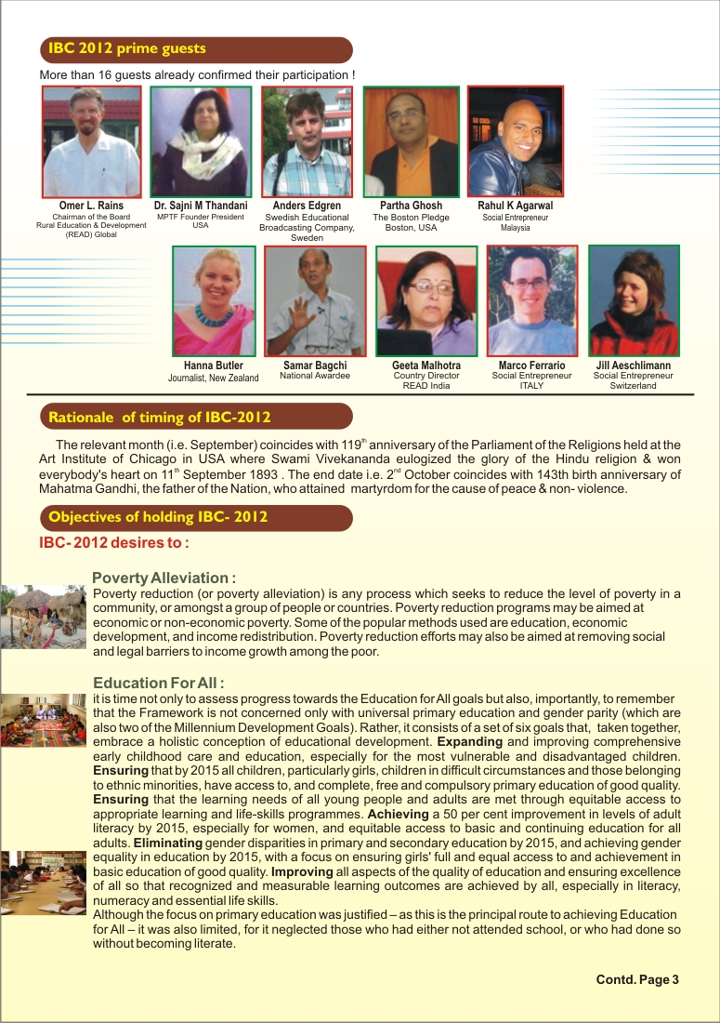
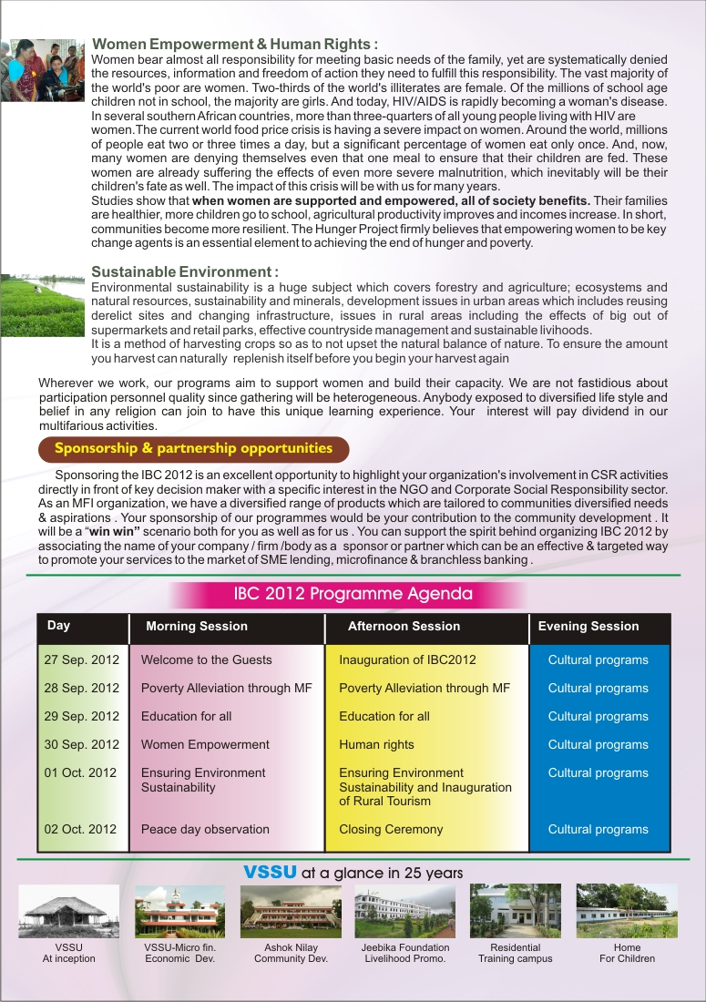
INTERNATIONAL BROTHERHOOD CONFERENCE 2012

In the midst of luxurious, pampering self-absorbed life, confluence with abhorrence, gluttony and above all repugnance among the religious doctrines, the gifted love for humanity is gradually obscuring. Humanity and values are slowly diminishing. In such decisive moment of our planet, VSSU wished to be hemmed, in the affection and love for each other, so that the sense of ‘humanity and fraternity’ is aroused in our hearts. With such a lofty idea, the people from fourteen countries of four continents, congregated at Ashok Nilay campus of Ullon village, Laxmikantapur in the South 24 Parganas district of West Bengal, on 27th September, 2012. VSSU humbly appealed to every global citizen, to join the International Brotherhood Conference 2012, and take a vow of fraternity. The conference was held from 27th September to 2nd October. The program was dedicated to the 150th birth anniversary of Swami Vivekananda. The International Brotherhood Conference was a six days congregation, with global representatives attending the conference.

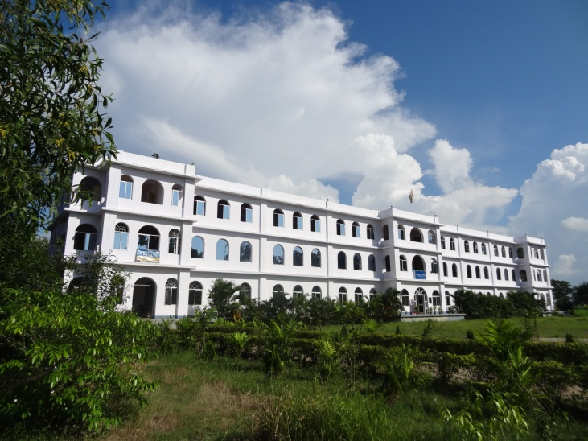

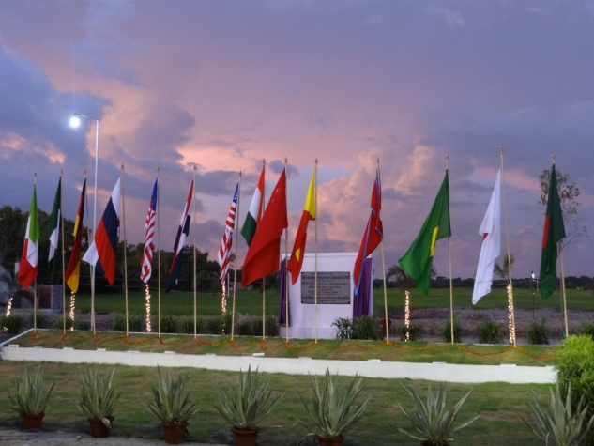

Inaugural address by Sri Kapilananada Mondal, Secretary-CEO, VSSU.

Namaskar!
The Chief Guest of the International Brotherhood Conference 2012, Hon’ble Senator Mr.Omer L.Rains, (Chairman READ Global USA),esteemed Consul General &Vice-Consuls, Hon’ble Representatives of different continents & countries, distinguished Govt,& Non-Govt. delegates, local administrative officials, Ministry of External Affairs, Ministry of Home Affairs, Dr.Sashadhar Purkait – President VSSU, eminent citizens, VSSU staffs, ladies & gentleman; I welcome you all in this august gathering, with gratitude and thanks.
The Vivekananda Seva Kendra-O- ShisuUddyan (VSSU), to mark the 150th birth year of Swami Vivekananda, the Silver Jubilee year of VSSU, and most admiringly the 10th year of the Holy Mother Sri Sri Chaitanyamayi’s arrival to the VSSU, has convened the International Brotherhood Conference2012.
It is indeed a matter of delight to say, that representative from four continents, fourteen countries are to attend the International Brotherhood Conference of VSSU at Ullon village of Laxmikantapur, West Bengal. The village Ullon, is nestled at the remote part of south twenty-four Parganas of our state, receiving very little socio-economic limelight. Naturally, an event of this stature is not only a local celebration, rather a tribute to the people of the soil of this part of the state.
An unfortunate local agitation, of this morning, has prevented the Hon’ble representatives of Bhutan, China and Nigeria from arriving here. I express my apology over the late inauguration of the conference, as we had been awaiting their arrival.
The International Brotherhood Conference (IBC) has been designed, keeping in view the World’s Parliament of Religions of 1893 at Chicago, wherefrom Swami Vivekananda had enlightened the world with his mesmerizing words. We begin our IBC on this very 27 September-which happened to be the concluding day of the historical Parliament of Religions. Our conference beginning today, would conclude on October 2nd, coinciding with the 143rd birth anniversary of Mahatma Gandhi. The end day has been named as ’Non-Violence Day’. Although, our six days’ program would touch upon many topics, the key message being-‘ A Peaceful World for All, through cultivation of Brotherhood & Humanity’.
Strong emotion sweeps over our mind, as we see the national flags of the four continents and fourteen countries unfurled this morning, in the soil of our dear village. VSSU strongly believes in respecting the culture & philosophy, contribution to global development, spiritual influence of every country, individual and organization. We feel blessed to have the opportunity of serving you all, present here, with our humble effort and arrangement. True love teaches the sense of responsibility. The Holy Mother whose hallowed inspiration, we treasure at VSSU,is fond of saying:”You open your heart, and you see all have become your Own. Every global citizen is your brother and sister.” The planet Earth is herself a mother to all of us. It depends on our sense of comprehension, as how much we widen our heart, dedicate our soul, and feel for each other. The more we accept each other with tolerance and humility, sacrifice and love, the better will be our effort to establish peace for everyone. Every peace initiative of us would benefit the present and the generation to arrive. The aim of this conference is to inculcate every soul, across the globe, in the spirit of love and peace.
The VSSU is serving the people and the land for the past twenty-five years. Our achievement, received so far, without much government or foreign fund support and our limited resource, would tell anyone, as how much work for the people could be done, if a country and its leaders feel to be dedicated for the cause of development. The object behind creating VSSU was to empower the weaker rural communities residing in the villages of economically backward South 24 Parganas district and to upgrade the quality of their lives by launching a number of community development &microfinance projects through mobilizing the community resources.
The IBC 2012 would focus on the Millennium Development Goal of the United Nations with attention to the philosophy of Swami Vivekananda regarding society development. The Swamiji had strongly felt for the Poverty Alleviation (“empty stomach understands no spiritual sermon”) Education & Health for all (“Education is the backbone of a nation and playing football is more helpful than reading scriptures, for good health makes a productive man.”), Women Empowerment & Human Rights ( “the survival of a society depends on both its male and female community, just as a bird needs two wings to fly, so are the two genders.”) Environment Sustainability (“The death of environment is the destruction of mankind”.)
As we stand on the backdrop of today’s trouble torn world, we, irrespective of our caste and creed, language and faith, intelligence and ability, solemnly acknowledge the fact that besides the advancement of technology and innovation, an inevitable destruction is heading our civilization, as more our fellow feeling is diminishing. The feeling of brotherhood in human mind is threatened today. Fortunately, for us, the rural environment and peasants of India still bear this treasure of human nature largely.
Friends and dignitaries, this is a glorious moment in the history of this country, as the world has assembled in this small village of West Bengal, to uphold the flag of Brotherhood. The esteemed Participants and Guests, who have come from across the globe, have very generously shouldered all financial liabilities to arrive here. With the people of this land, VSSU joins to express its deepest gratitude and thanks to you all. The inspiration that would emanate from this conference, would lead VSSU towards a greater service of humanity.
The coming six days of conference would surely be of joy and understanding, sharing and caring, through your cooperation and kindness.
I once more, convey my sincere thanks and gratitude, to all who are present here and to those who could not physically attend, but played a vital role in making this program a great moment.
May I, pray to Almighty, that your life be full with happiness and activity. My esteemed regards to all.
Jai-Hind
Namaskar!

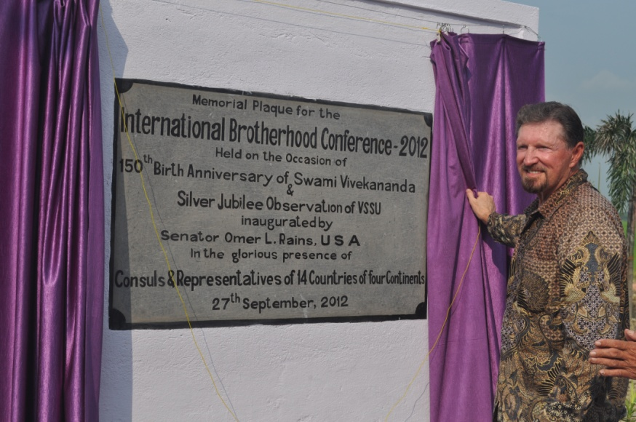
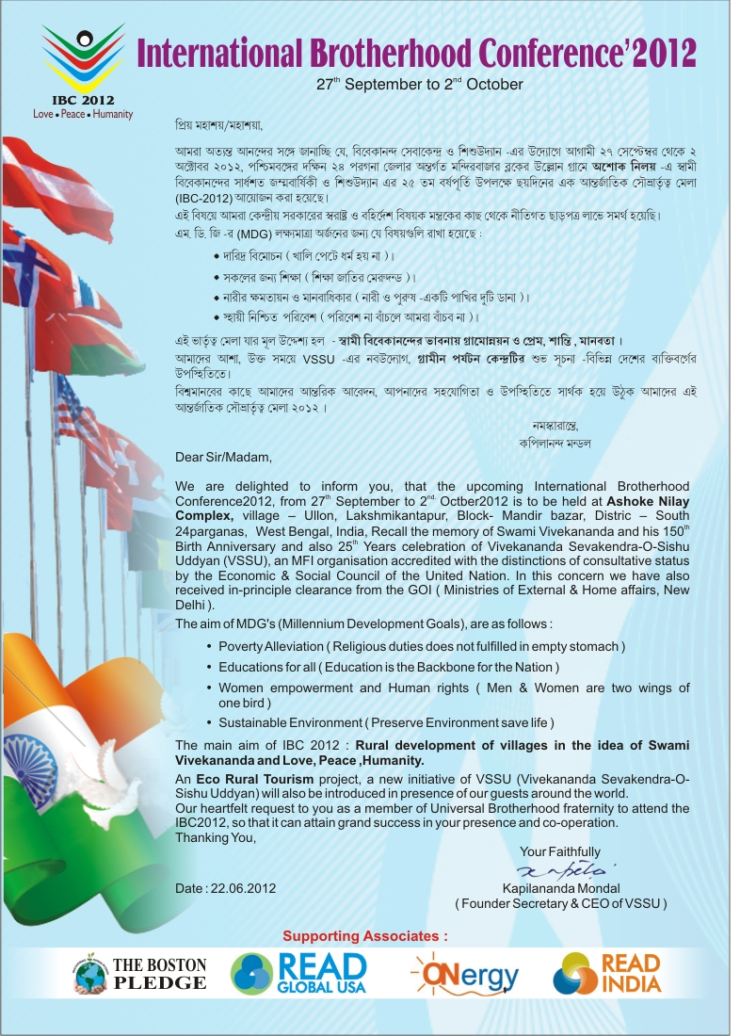
Key Note Address by Hon’ble Senator Mr.Omer.L.Rains Chief Guest, I.B.C. 2012.
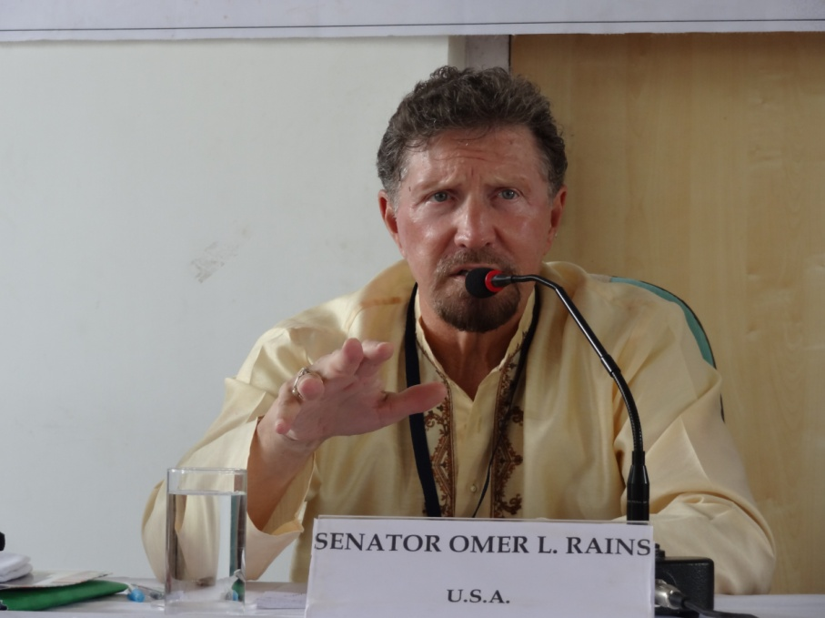
Thank you and Namaskar. One and all, Honorable Chair, Distinguished guests from throughout the world, Colleagues, and Friends of Ullon and VSSU. First of all I want to tell you how honored I am to be here with you and to have the privilege of inaugurating this important international Conference. This Conference is especially meaningful to me as I feel such a part of this community. The first of my 5 visits to Ullon was in 2007 when READ Global READ India selected this village to be the first of what will eventually be scores of projects in this great country designed to promote literacy to create jobs and empower women. That project became the Oceanic Library, a complete Community Resource learning Center. It gives me great pride to have played a small role in helping to establish and promote the Oceanic Library over the last 5 years; although the principle credit for the Oceanic Library obviously belongs to the village of Ullon itself.
On my first visit in 2007 , I had the distinct honor and opportunity to meet Kapilananda Mondal, a truly great man who is recognized as such in the International community , and also many other wonderful people in this very special place. At that time I also came quickly to realize how VSSU in helping to change not just the village of Ullon but also much of West Bengal and of India itself. VSSU has how taken its message to over 20 countries, many represented here today on four continents. It is an illustration of how one village can make a historic difference, not just here but throughout the world. Indeed, that this international conference is being held here, speaks to the important recognition the international community is giving to this village and to VSSU .It is truly remarkable.
From this spot, during the next several days the people of the world will learn about ways to address poverty, to advance educational opportunities, to promote human rights, to empower women and to preserve and sustain the environment.
It is also appropriate that this Conference takes place on the 25th anniversary of VSSU and the 150th birth anniversary of Swami Vivekananda who stressed in his teachings the richness of diversity and the international brotherhood of man.
Over the next several days, the principles of world harmony and peace, taught by Vivekananda and stressed by VSSU will be discussed in plenary sessions and seminars, as well as illustrated by way of exhibitions and cultural events.
As I indicated when I began these remarks, & an honored to have the privilege of inaugurating this conference and I look forward to learning much more from the various sessions and exhibitions that will follow.
Thank you, and may we see peace everywhere in the world in our lifetimes.
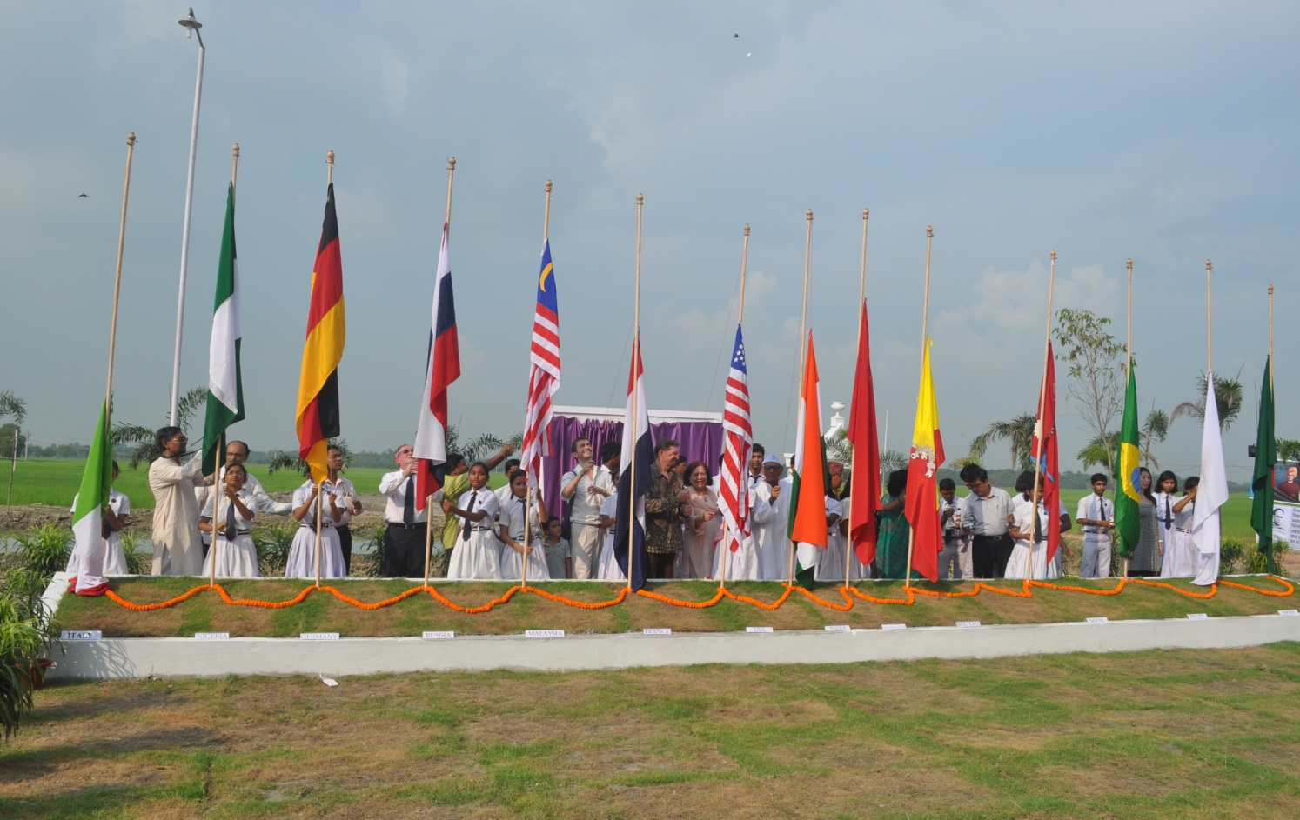
Namaskar,

Conference Comments
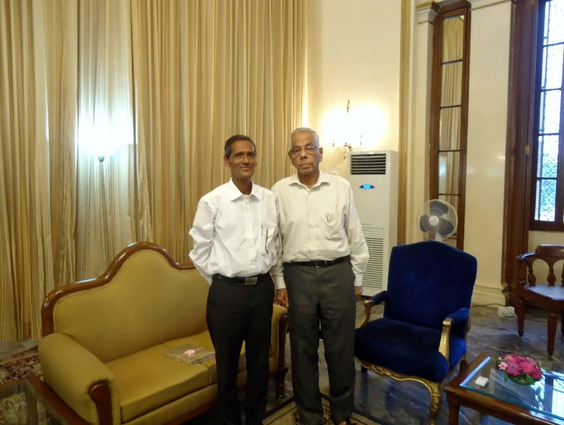
IBC 2012.

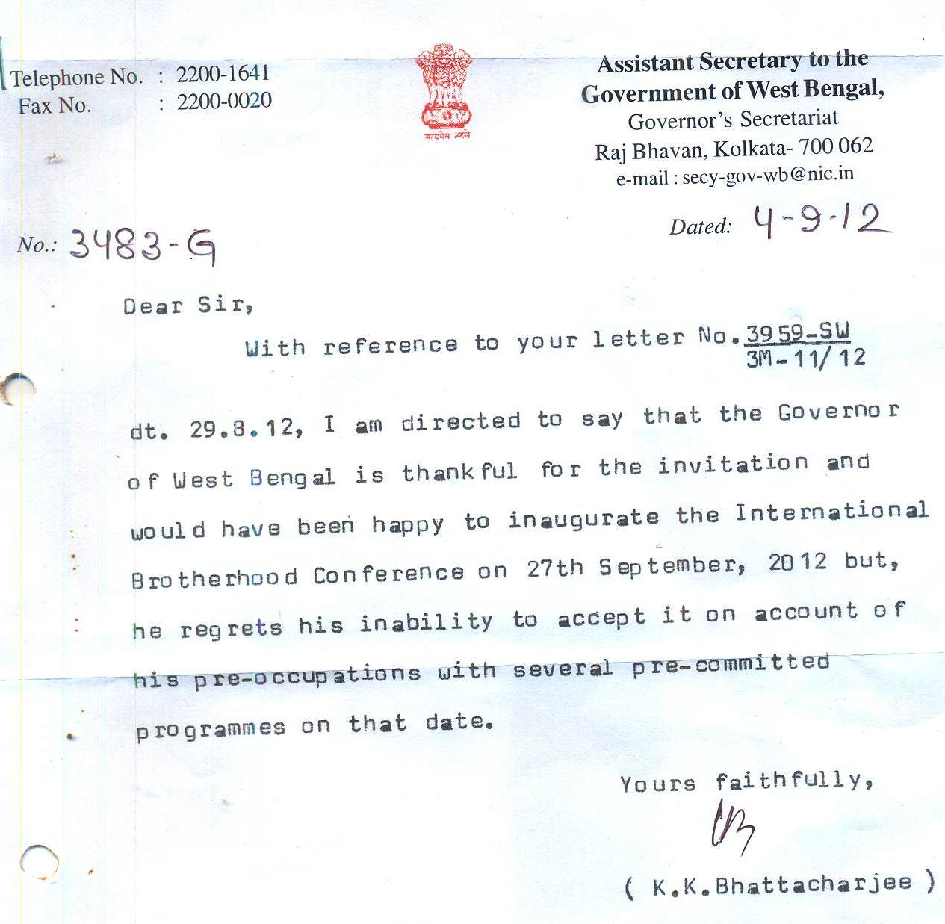

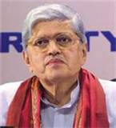
Hon’ble Shri Gopal Krishna Gandhi, Former Governor, West Bengal
Esteemed friends,
“I am touched by your gracious mail and honored by the kind invitation it brings.
But you have to excuse me. I am committed by previous arrangements to other things at and around that time. I will be unable to make it to the important event you are organizing. The loss is mine. Please accept my sincere regrets and my namaskar.Best Wishes to VSSU and IBC.”

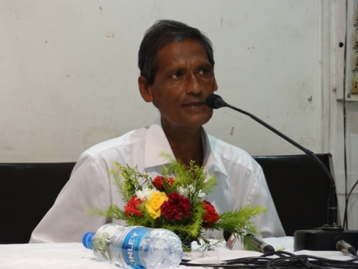
Shri. Kapilananda Mondal, Founder Secretary & CEO, VSSU.
“This is a glorious moment in the history of this country, as the world has assembled in this small village of West Bengal, to uphold the flag of Brotherhood”

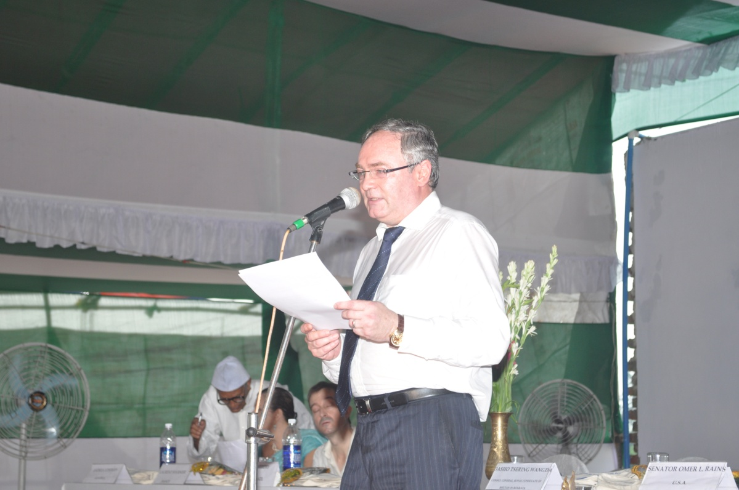
Mr Alexander V.Mazirka
Hon’ble Vice-Consul & Director
Russian Center of Science& Culture in Kolkata
“ The human race needs more such VSSU to combat the miseries of rural life....I am amazed to see the vast amount of work done over the past 24 years, and wish this organization the very best”

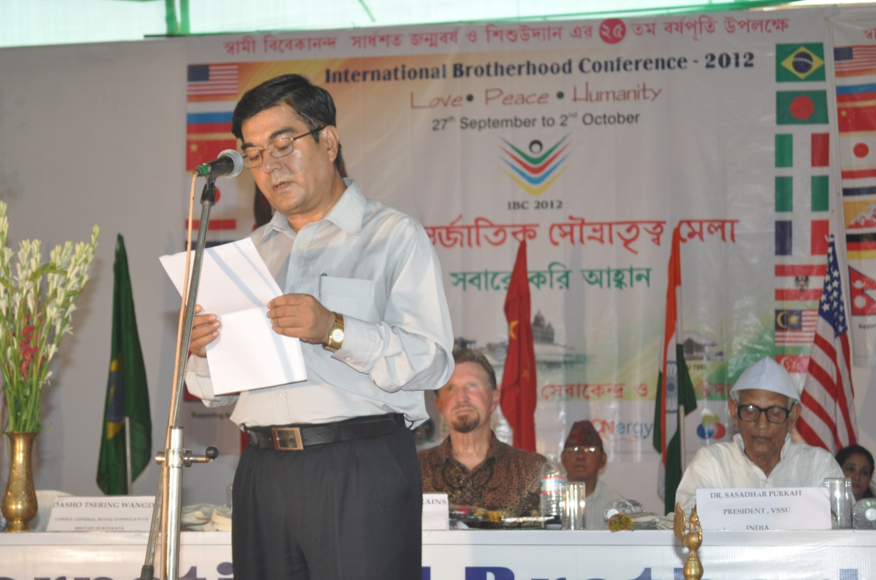
Mr.Rameswor Paudel
Hon’ble Consul-General, Nepal

“I am delighted to be here to inaugurate the IBC 2012 and wish you all the very best. May the noble cause for which VSSU has dedicated itself, be blessed by the poor and the downtrodden for whom this organization stands.”

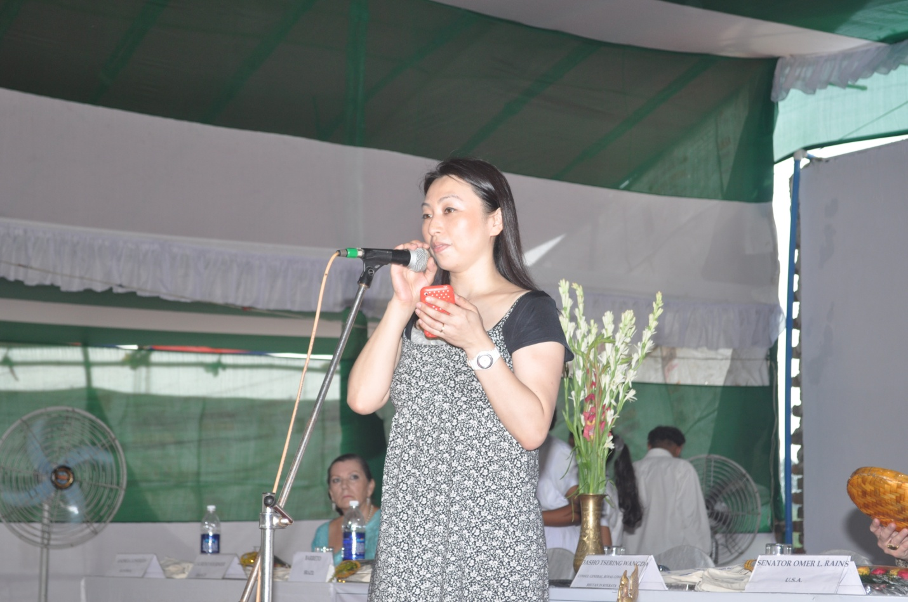
Mrs.Naomi Isemura(Khan)
Representative- Japan

“I feel honored to join the International Brotherhood Conference in your 25th anniversary.
In India, I see many poor people facing a problem of food, accommodation, medical care and education. At the same time, there are a plenty of supporting system like VSSU.
I am sure, your great contribution to the society to solve the issue of poverty will widely be accepted appreciated in the community. I hope VSSU will develop peaceful and sustainable programs continuously.”

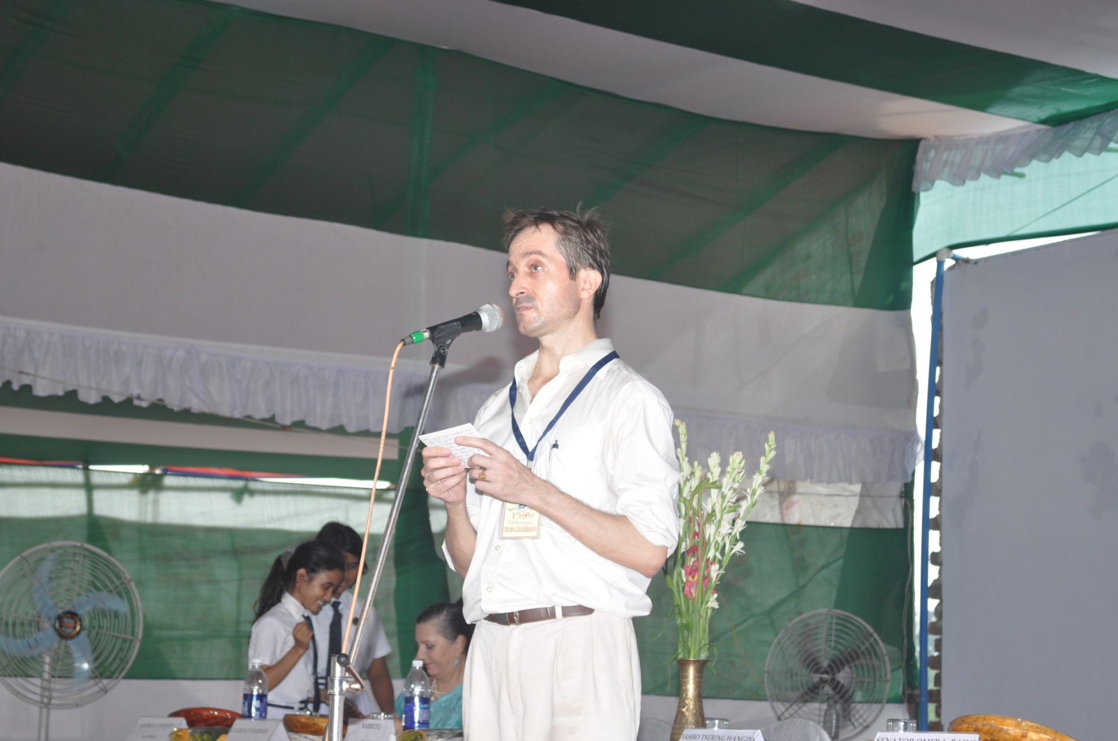
Mr.Laurent Fournier- Representative, Republic of France

It has been a true honour and a real pleasure to be here at VSSU.I regret I was unable to attend the full program, but believe it was a great time.

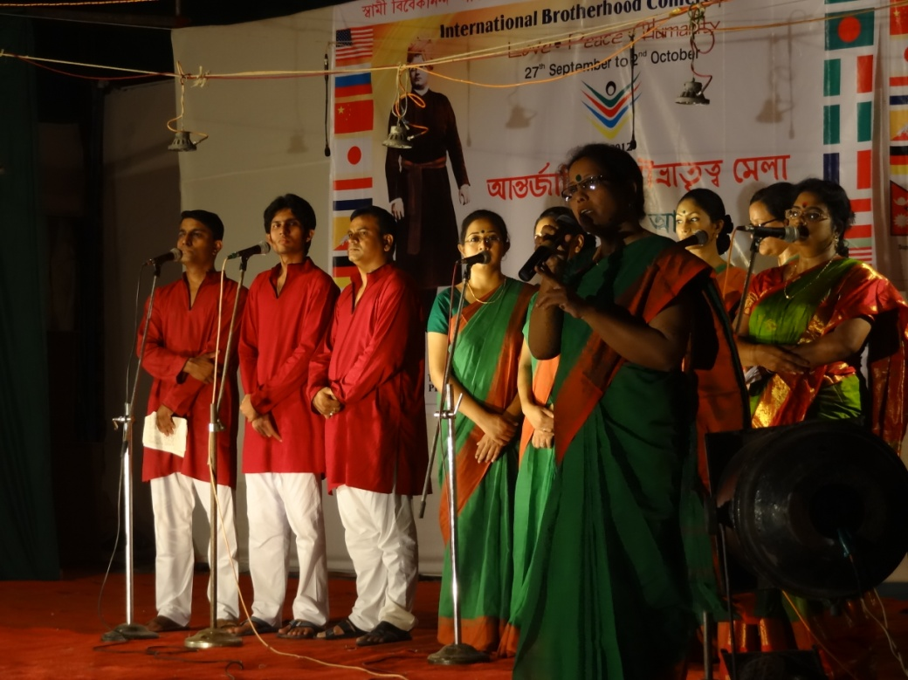

Smt. Kaberi Sengupta, Principal, SANGEET BHAVAN,
Chittagong, Bangladesh

“On behalf of ‘SANGEET BHAWAN’, Chittagong, Bangladesh, I express my boundless gratitude to you for giving us the scope of participating in the auspicious IBC Conference, where artists from different countries of the world participated, and made the seminar successful in every respect and crowned with glory. The charming glamour, name and fame of your institution, shall never perish from our memory.
I believe the exchange of views we had on various aspects of our activities would strengthen our relationship, which will be very much helpful for our future activities.
I earnestly hope that the friendly relationship between your institution and Sangeet Bhavan, would prosper in the days to come.”


Ms.Kelsy Hoffman
Saint Louis ,Missouri

“I am so happy to be with VSSU and proud to have been a part of an organization that cares so much for its community and the world at large. I wish you all the best and am sure you will do great things.”

Mr.Jorn Duwel, Mr.Michiel Tramper,Mr.Sjoerd Vonk
Delft University of Technology, The Netherlands

"Although we arrived at the last day of the IBC conference, we felt very honored and surprised at the same time to be welcomed as special guests at the International Brotherhood Conference. For us, it felt like a warm welcome of the country of India. We were glad we could share the reasons of our stay and our feelings on brotherhood. We hope this conference would lead to a greater insight in the Truth and community sense."

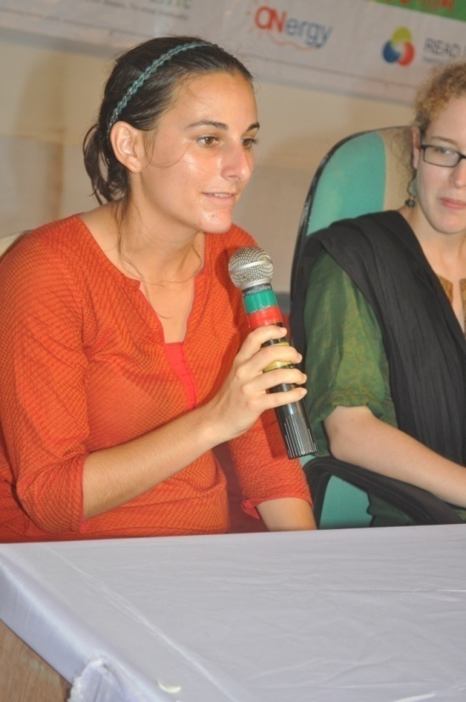

Ms.Claire Austin Representative, U.S.A
“I was much honored to be a part of the 2012 IBC at VSSU from 30th September to 2nd October. This was my first visit to VSSU, and I thought the campus and buildings were as beautiful as the village of Ullon itself! I enjoyed speaking with other environmental entrepreneurs, as well as learning more about VSSU’s program. The conference was an excellent tribute to Swami Vivekananda and to VSSU. Thank you and I am very much looking forward to returning to Ullon.”
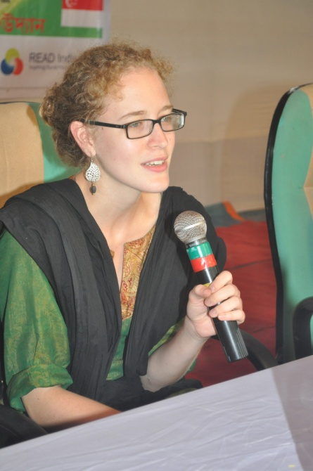
Ms.Elizabeth Peyton, Representative U.S.A.

“I was so honored to be a part of the International Brotherhood Conference. I believe that initiatives such as this are an inclusive way to raise awareness about different issues like human rights and environment sustainability.Ultimately,it is these approaches that empower people to participate in making their own futures and raising the care and value with which we treat our environmental resources and other people.I am excited for the potential that this conference holds to bring together more people and start new dialogues.
Thanks so much again, for the invitation and your continued support. I appreciate it very much and am very excited to continue this relationship while I am in India.”
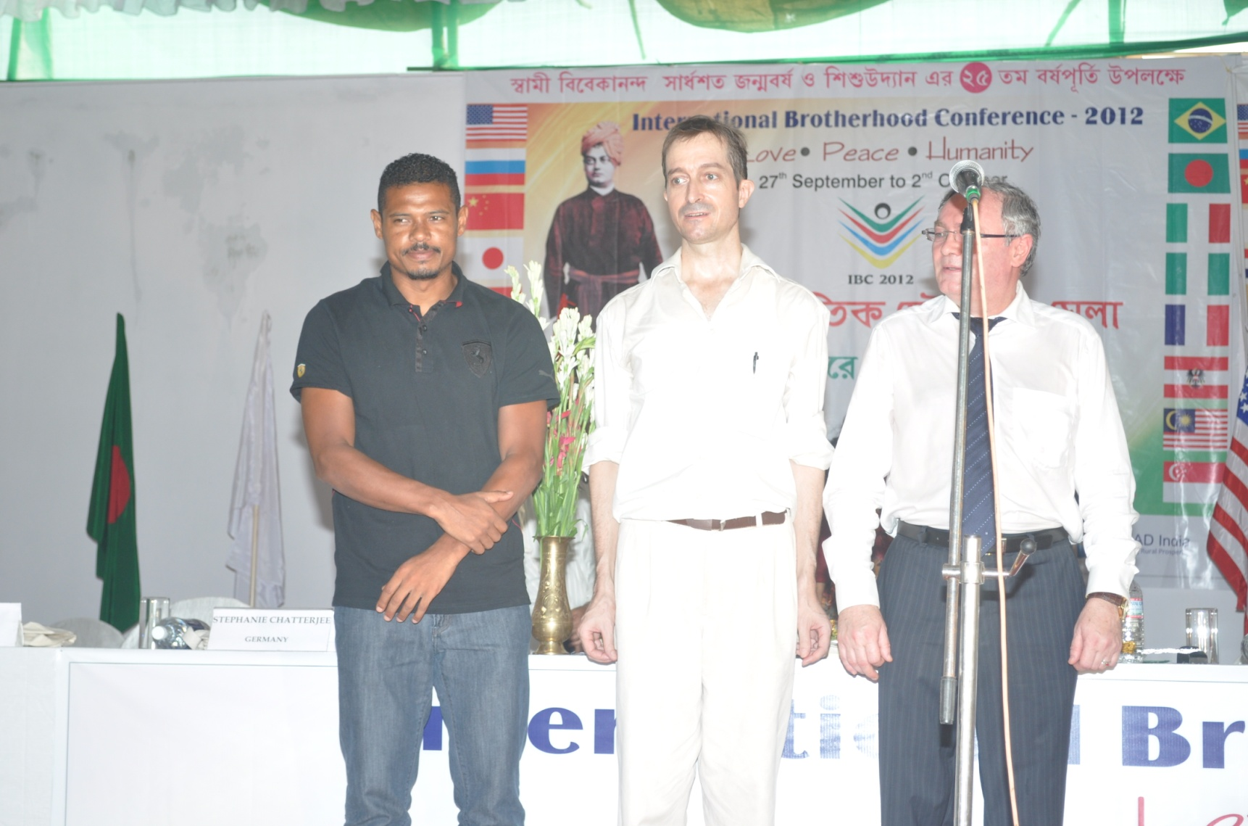
Mr.Jose’ Ramirez Barreto, Representative of Brazil
“Best wishes to VSSU for organizing the conference, and including my country.”

Advancing the Promise and Resolve of Lakshmikantapur and VSSU to New Heights
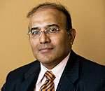
Mr. Partha S Ghosh
Founder-Chairman
The Boston Pledge
Dear Friends, Ladies and Gentlemen,
Let me begin by paying my deepest tribute and highest reverence to Swami Vivekananda on His 150th birth anniversary, a personality who transcending - geographical boundaries, limits of time, lines of inquiry, - continues to inspire humanity and will continue to do so for generations to come.
No other place in the world be most befitting, is most appropriate, to host such an event as Lakshmikantapur. It is a place, where its people, its children, and most importantly KapilMandal and VSSU have proven to the world, how the teachings of Vivekananda, his values and beliefs when practiced with full faith and full dedication, major socio economic strides could be made.
Kapil Mandal, and Lakshmikantapur, thank you for providing to the world such a model for development, thank you for providing the opportunity to The Boston Pledge to work with you and thank you for inviting me to this International Brotherhood Conference.
I am indeed sorry that I could not be with all of you in such a great event; I am honored that you have given me the opportunity to share a few thoughts on such an occasion through one of the dedicated members of the Boston Pledge and a great fan of Lakhiknatapur, - Dipayan Banerjee.
- Swami Vivekananda’s vision of India (Pre-partition = South Asia) is indeed a Vision of Vedic India; I see in Vivekananda’s vision, - a vision of India which I cherish, - which provides every person the opportunity to express their inner talents bound together by values and beliefs of Vedic Philosophy which celebrate the universal spirit of man and hard work ( Karma Yoga).

In Lakshmikantapur, we see the microcosm of the Vision of India at work, I hope it will soon inspire villages all around the world to begin their development paths

- Kapil’s focus on micro finance, on micro ventures, micro thoughts (I mean children) is impressive and his desire to extend the power of micro movements to different parts of the world through International brother hood is a great step in the right moment.

- We also believe our planet to survive we need new kind of innovation, – which I call “bottom up innovation”. In that spirit, on behalf of The Boston Pledge and in honor of my mother who was a big support of The Boston Pledge, and has always asked us how are work with Lakshmikantapur is progressing, we will like to establish a Rural Innovation Center, first of the kind in the world, right here within the premises of VSSU. People will innovate solutions to their problems, - which are affordable and eco friendly, which could be taken around the world in similar environments.

VSSU and Kapil have demonstrated how dedicated and intelligent work could make a difference, so on the 150th anniversary of Swami Vivekananda, a big proponent of Innovation, let’s hope The Boston Pledge Innovation Center at Lakshmikantapur will become a compelling force of New India and a more enlightened world. Thank you.

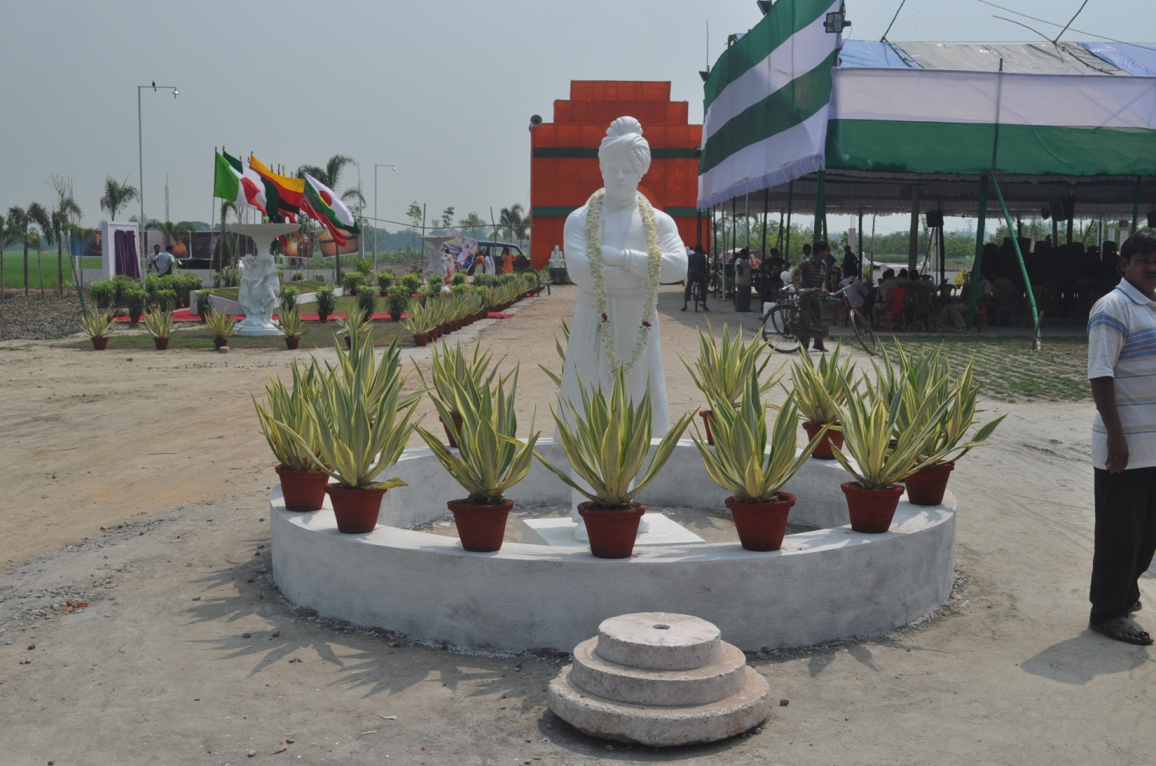



The Honourable Julia Gillard MP, Prime Minister of Australia
Department of the Prime Minister and Cabinet
“ The Prime Minister wishes you every success with your preparations for the conference and has thanked you for extending your invitation to her.”
Maria Tsirbas,Assistant Secretary Asia,Americas and Trade


The Right Honourable David Cameron MP, Prime Minister of the United Kingdom
10 DOWNING STREET, LONDON SW1A 2AA
“The Prime Minister has asked me to thank you for inviting him to the International Brotherhood Conference. The Prime Minister really appreciated this thoughtful invitation and was grateful for the offer to attend the conference. However, owing to the enormous pressures on his time at the moment, he is unfortunately not in the position to commit to any more engagements. He wishes the IBC a great success.”
Correspondence Officer, Office of the Prime Minister.

European Central Bank

“On behalf of President Mario Draghi, I should like to thank you for your invitation to be present at the International Brotherhood Conference at Lakshmikantapur from 27 September 2012.We wish you every success for the IBC 2012. With best regards.”
Regina Karoline Schuller
Head of Press and Information Division



Honourable Dasho Tsering Wangda
Consul General, Royal Bhutan Consulate, Kolkata
“Greetings from Royal Bhutan Consulate- to VSSU for organizing International Brotherhood Conference 2012.”



Ministry of Finance
Govt. of India
“The Finance Minister Shri Pranab Mukherjee,is sending his best wishes for the IBC 2012.”
Rajneesh,IAS, Private Secretary To Finance Minister,New Delhi

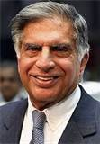
Honourable Shri Ratan N Tata,Chairman,TATA Sons Limited
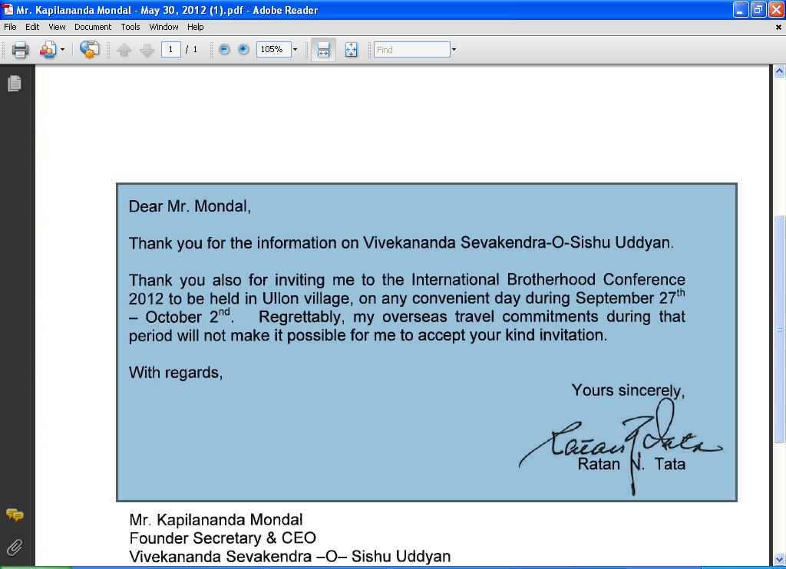

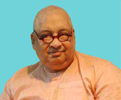
Rev.Swami Nityananda
Secretary, Ramakrishna Vivekananda Mission, Barrackpore
“Thank you very much for your letter inviting me to attend the Conference as a Speaker. I am unable to accede to your request because of my physical limitations. I have been confined to bed for the last three months, and I regret I shall not be able to go to your place to deliver the lecture. I wish all success of the Function. With best wishes and blessings of the Lord.”

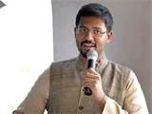
Mr.Vinay Jaju, Founder- ONergy
“It has been an absolute pleasure and honour to be able to attend and be part of the IBC 2012.Such a vision and program can only be expected from an organization like VSSU.I thank you for the inspiration and inviting ONergy.”

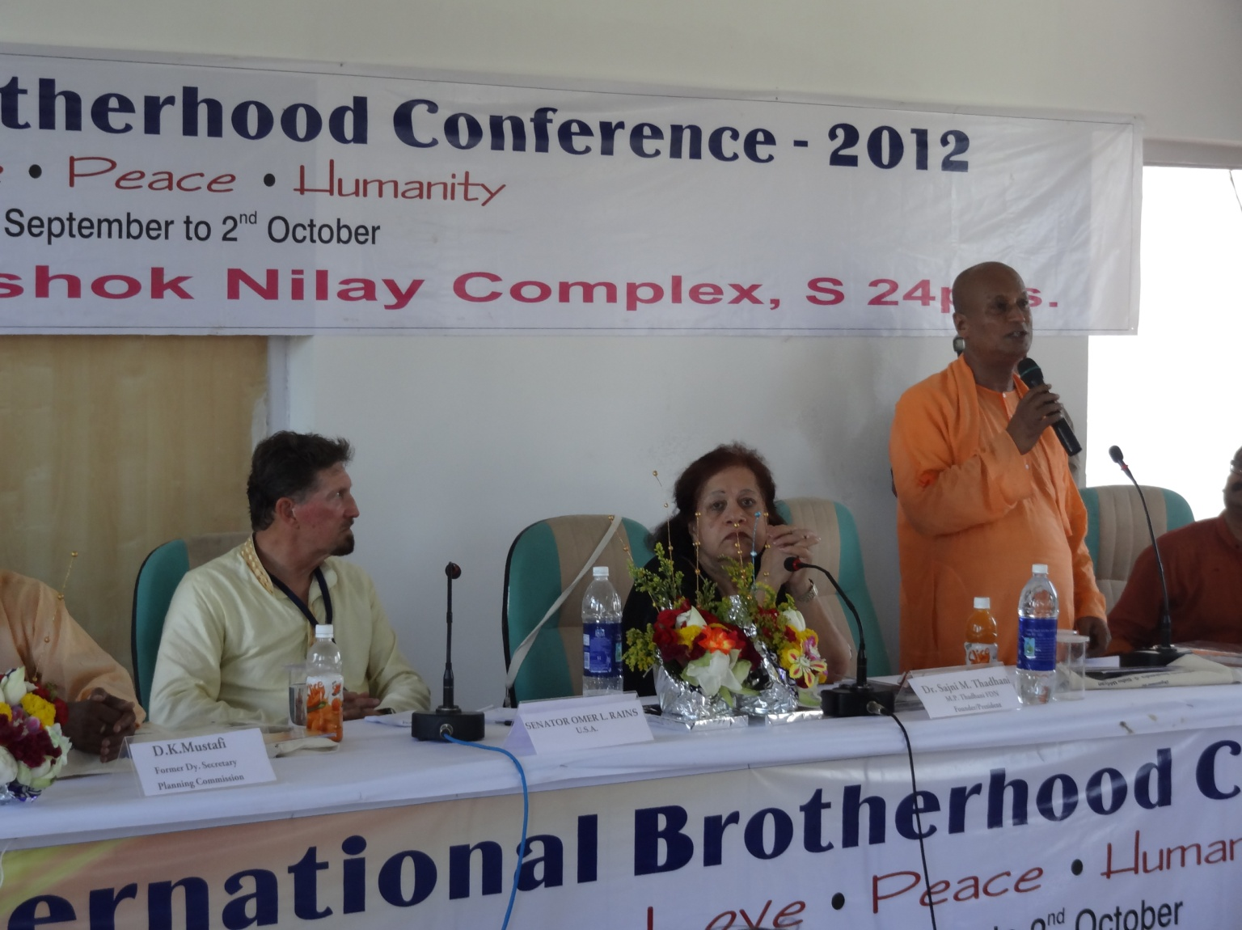
Rev.Swami Suparnananda
Secretary, Ramakrishna Mission, Narendrapur.

“The society tends to ignore and oppress our Mothers & Sisters...the females...here stands VSSU, so very unique with its noble projects of Women Empowerment...this is the true worship of the Mother Goddess”
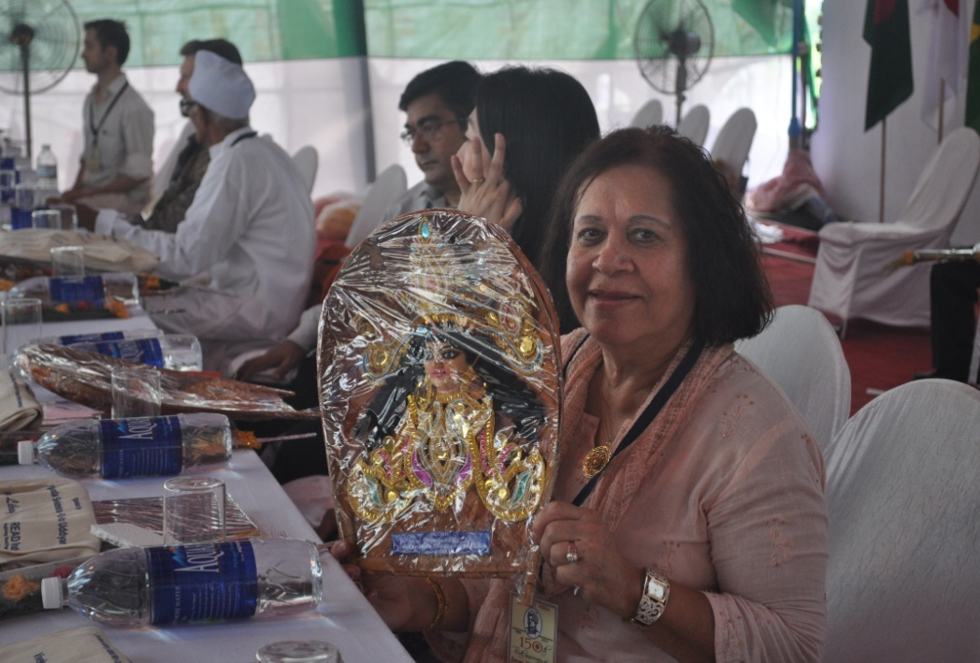

Dr. (Smt) Sajni M. Thadhani, MPTF Founder-President
“The Conference Agenda, focusing on UN Millennium Goals and integration of the same with local development focus by VSSU was of great importance to all participants in the development field. The panel discussions and interactive sessions raised awareness of the local, as well as, international people present at the meeting.

I was particularly interested in MDG(s) related issues, and their interplay with Human Rights to Development Agenda. To that effect I was able to partake in those discussions, and hopefully contributed to greater learning on everybody's part.

The 25th Anniversary of VSSU, and the Celebration of Swami ViVekanandji's Birthday was well organized within the conference framework. The variety of cultural programs were very good. A great and complex presentation by you and VSSU team.”
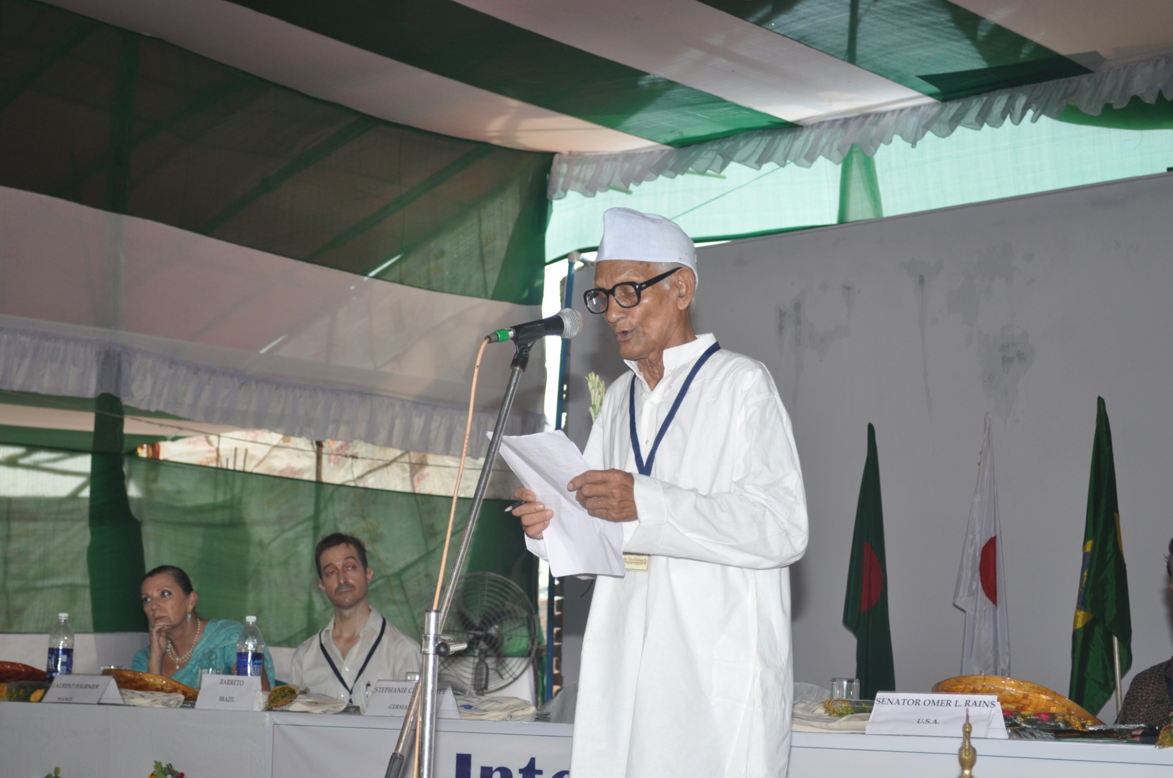
Dr.Sasadhar Purkait
Hon’ble President-VSSU

This is just the first of three votes of Thanks I have been requested to offer during the Conference which brainchild was given birth to with the help and effort of so many wonderful persons, our members, friends, well- wishers and our faithful and diligent staff of VSSU. Particularly I offer my thanks to our generous sponsors and benefactors…
Last, and not least let me offer to the convener of the IBC 2012, Mr. Kapilananda Mandal, to Prof. Dr. Andrea Loseries, who has joined last minute for co-ordinating the Academic Program and for today’s Moderation, and to all others of the IBC Organization Team a heartfelt thanks.
May those dignitaries who leaves us now have a save journey back home or to their offices. And may the other invitees who stay on with us for the Conference gain some insights and inspiration for achieving the declared Millenium Development Goals on which this conference academically is based.
Sarva Mangalam

Precise Environmental Management is the Ultimate solution to Poverty Eradication; A case study of South Bengal, West Bengal, INDIA.
Dr.SUJIB KAR
Speaker: IBC Academic Session
All the questions in the analysis of poverty have their own answers in the nature. The poverty eradication is possible by precise environmental management.
We are leaning towards the growth and development, without thinking about the consequence. The various phases of development are directly or indirectly affecting the environmental & ecological balance. Our policies are also destroying the heritage biodiversity region of the Sundarbans. Some examples are:
1.) Global warming was a blessing for the counties located in cool temperate belts of one world because it was decreasing the prolonged winter of that area. In the last 5 to 6 years, maximum icefalls have occurred in various parts of the cool temperate belts, as miniature ice age. Thus, causing excessive contrast of temperature in the upper and lower layers, as well as unequal Radioactive decay of minerals of the earth’s interior, increasing the mobility of the plates causing vigorous earthquakes. The global warming is also increasing the sea level by melting the various ice sheets and glaciers, in the various parts of the world. Since long, it was observed that water quality in the coastal area is degrading. Drinking water will be unavailable in these areas in the days to come.
2.) The unrestricted growth of population has caused excessive pressure on natural resources. Developing multi storied building and various other structures have damaged the isostatic balance of the surface. Subsequently, hampering the recharge and discharge of ground water, flow of surface run-off and normal rhythm of the hydrological cycle.
3.) Soil erosion and pollution, water quality degradation easily hampers the agricultural productivity causing health hazard. The result being increased vagaries and poverty.
Lack of long-term prediction in field of physical environment
India is a land of monsoon. The departments of meteorology give a predication of 24 to 48 hours in the meteorological phenomena; this is insufficient in the field of agricultural planning. That is why crop failure is the normal occurrence thus increasing the level of poverty.
Management Plan
Observation of the evolution of Bengal Delta shows, that it has evolved in successive stages and phases. Thus, the litho logical arrangements have occurred over the Bengal Fan. All the water-bearing straits are extended horizontally over this fan, which may carry water as the ephemeral stream of water or sub-surface flow of water. Such typical rock layers are not capable of holding water, which is causing seasonal fluctuation of ground water table in various parts of South Bengal and is affecting agricultural productivity.
Since long time, various planners and authorities have tried their level best to control the flood and drought of South Bengal and they have developed various dams on river Damodar, on Ganga at Farakka and on Teesta without thinking about the regulation on the recharge of ground water. We are thinking about the water distribution policies in the national and international level without much attention to the consequences. Here, in this context, if we go through the actual geological structure of Bengal Delta then it will be observed that in the various phases of the evolution of Delta, series of faults have developed in various parts. These faults have distorted the litho logical arrangements largely. Depending on these fault lines mainly BASIN- MARGIN fault, EOCENE HINGE, MID-PLIOCENE fault and PADMA-PABNA fault etc., can easily indicate the physiographic variations in the context of the evolution.
If policy makers, in various levels, develop some under ground barricade through these fault lines up to 40 to 50 mts., deep they will be able to control the subsurface flow and ephemeral streams. These barricades can easily control the movement of surface and sub- surface flow, not only that they may also balance the seasonal fluctuation of ground water table .Afterwards, it will be observed that no dams on the natural flow are necessary. It may also balance Arsenic contamination of ground water and salinity of water in the saturated and un saturated layers of water specifically Arsenic and Salinity are hampering the daily life in various parts of South Bengal as well as causing failure in Agriculture with increasing Health hazard.
On the other hand, if we develop important roads upon these barricades then we may easily connect the various parts of India with Bangladesh, Shillong, Tripura, and Mayanmar.These roads will decrease the distance between the important towns largely.
Our city kolkata may become the main business center of northeast India and South-East Asia.
As the Ganga delta is composed of loose sand and clay so, it is clear that any type of seismic shock can easily disrupt the layers of sediments and propagate the sliding nature of the alluvium of the delta. That is why, minor Earthquakes may also have vigorous impact on this area. It is observed that there are series of faults at the delta fronts, which may cause Earth quake in the Sundarbans area at any time.
These barricades may easily save the delta from powerful Earthquake by controlling the movement of rock layers. At the same time, the whole North-East India could be saved from such seismic activity. Thus, such condition will save delta from its vulnerability and increases the sustainability of Kolkata, Dhaka, Guahati and Shillong town etc. Hence, multipurpose and multidimensional landscape planning is necessary for the sustainability of a region as well as for its balanced growth and development with eradication of poverty.

The IBC Visitors

INDIA (Host Country)



From left: Italy, Nigeria, Germany, Russia, Malaysia, France, U.S.A. China, Bhutan, Nepal, Brazil, Japan, Republic of Bangladesh
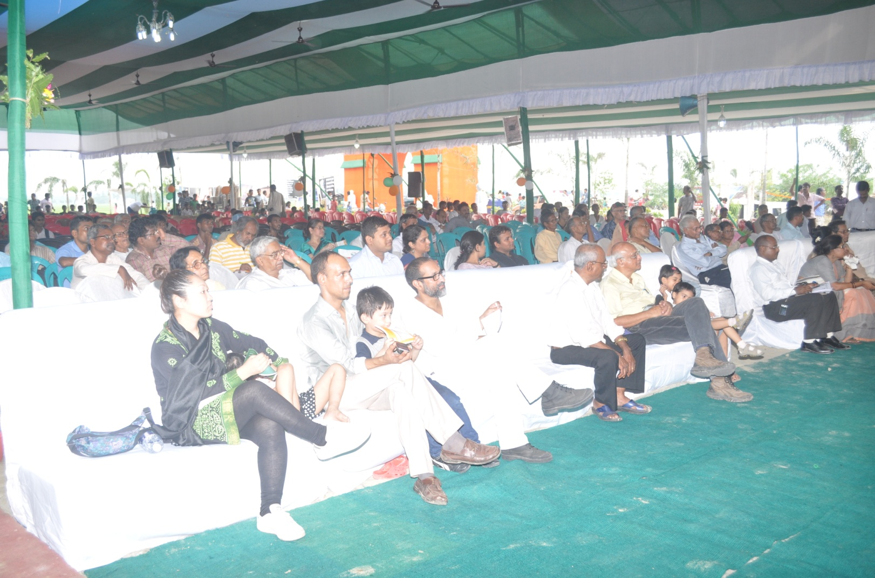
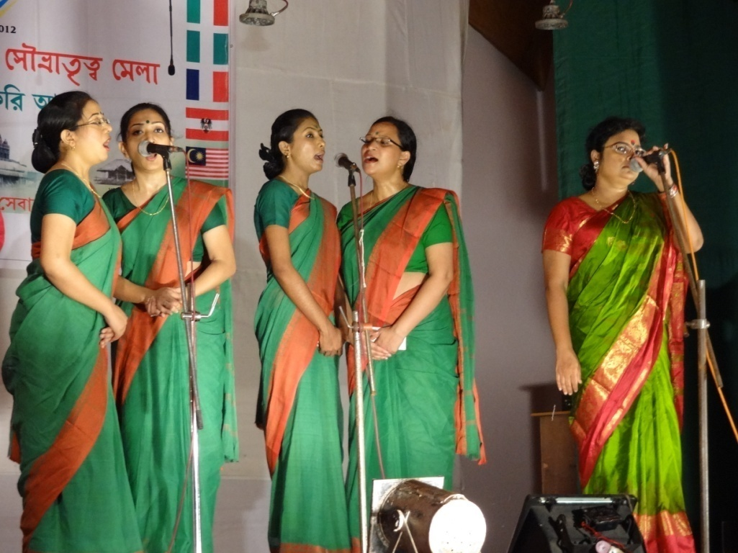
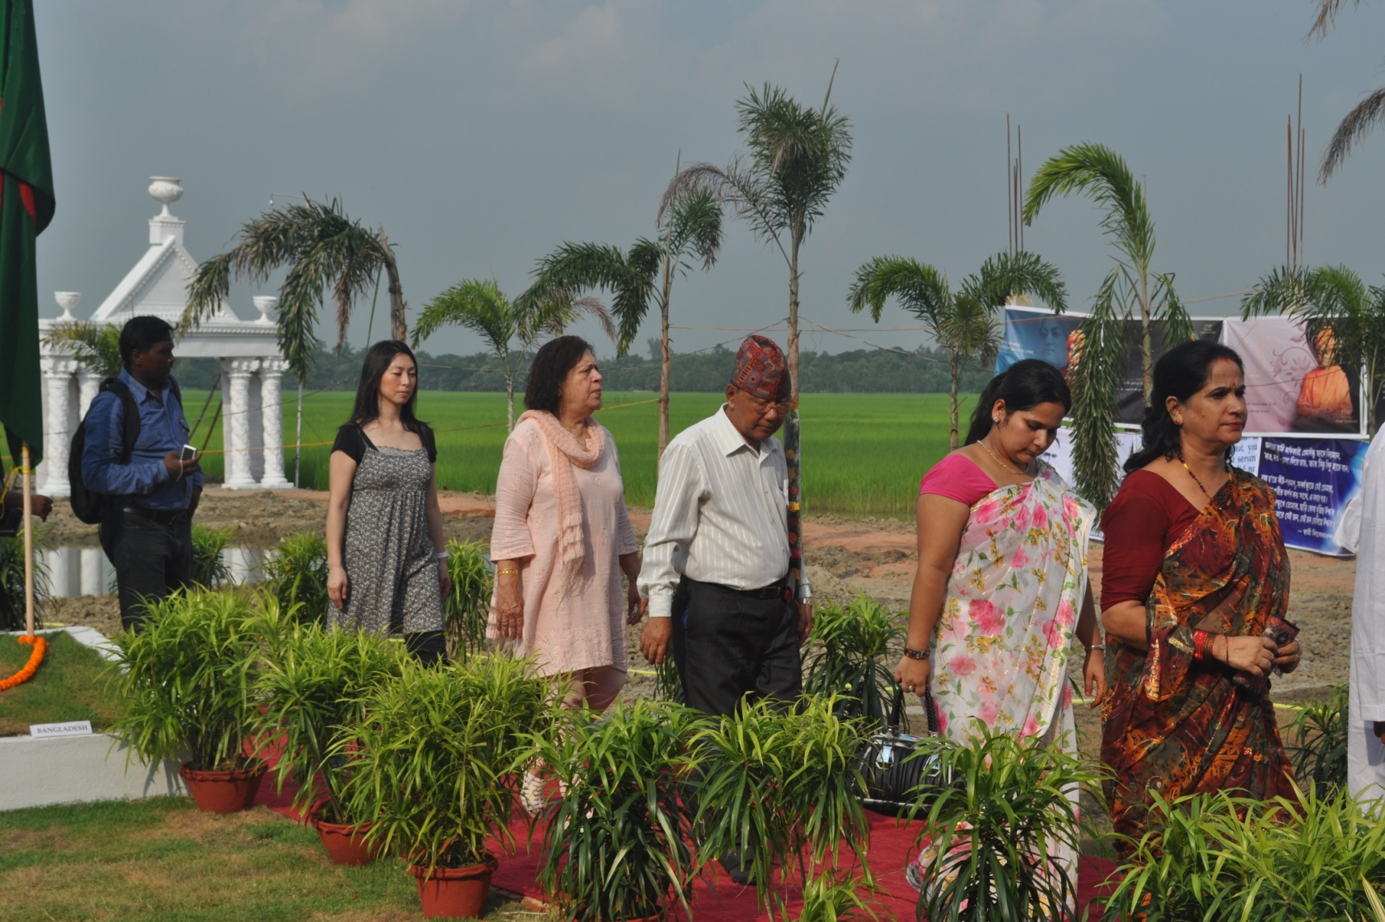
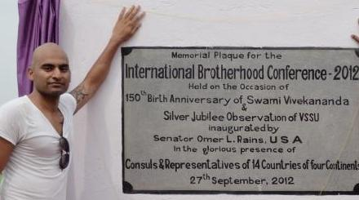
Mr. Arjun Thapa
Mr. Rahul K Agarwal
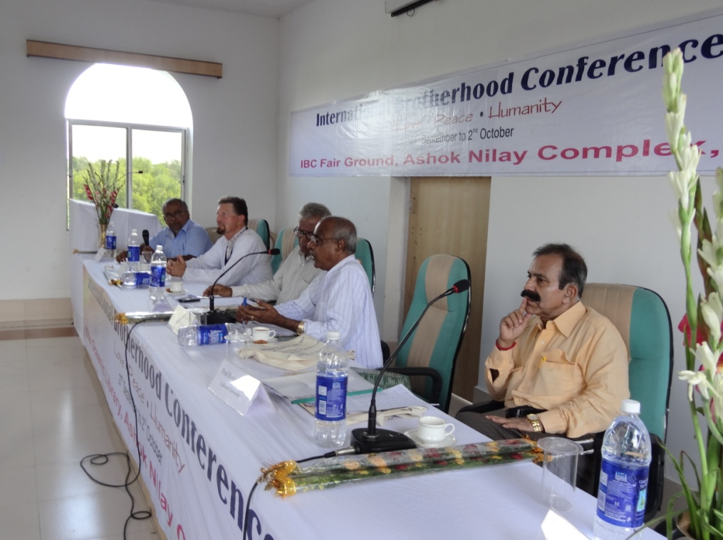
Mr. Rajen Varada
Poet Mili Chowdhury
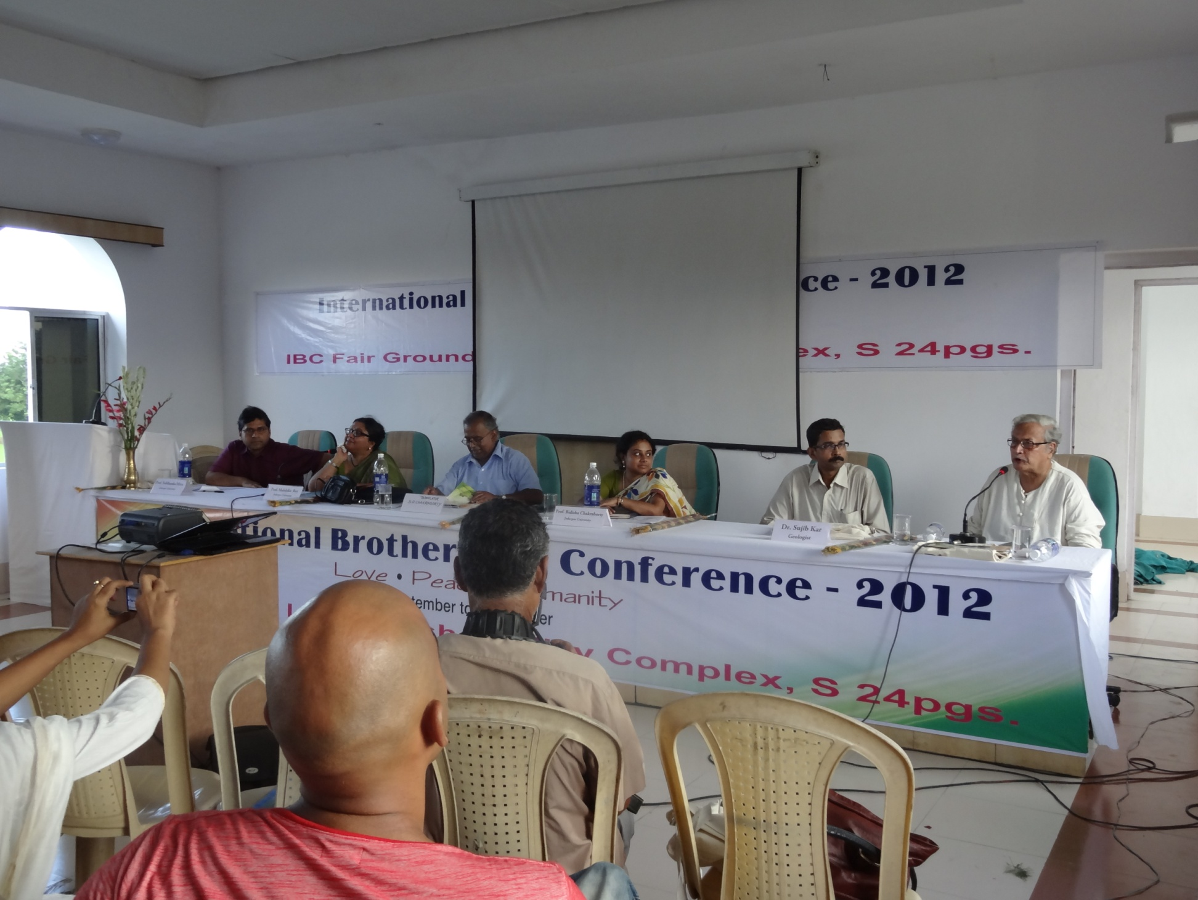
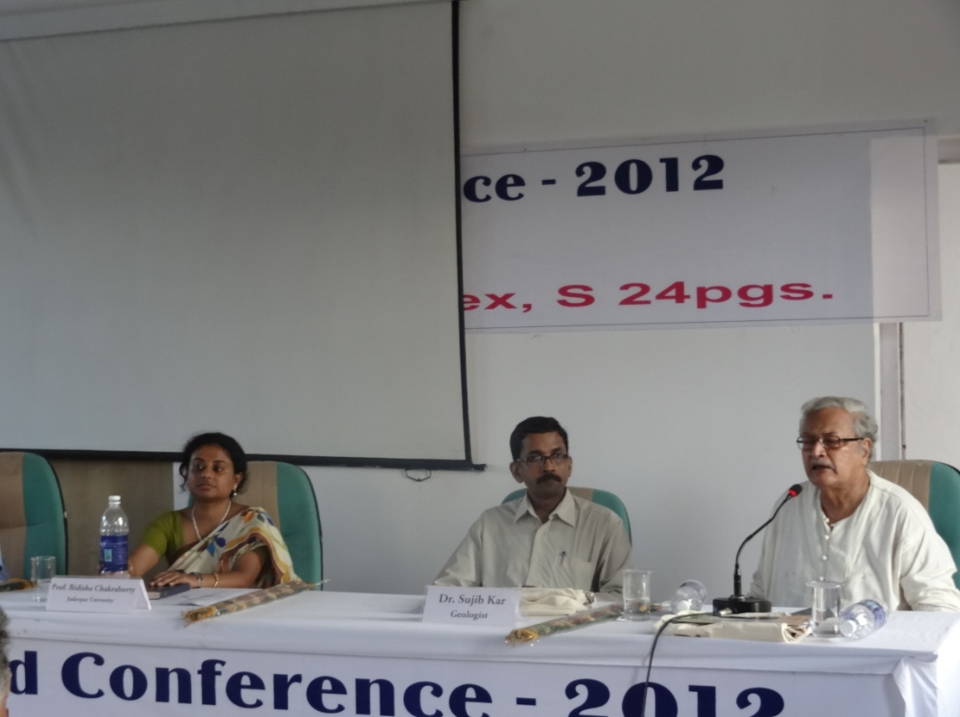
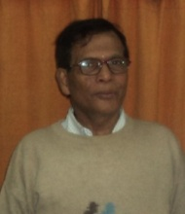
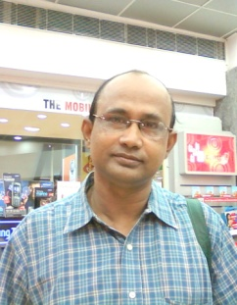
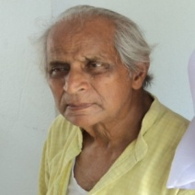
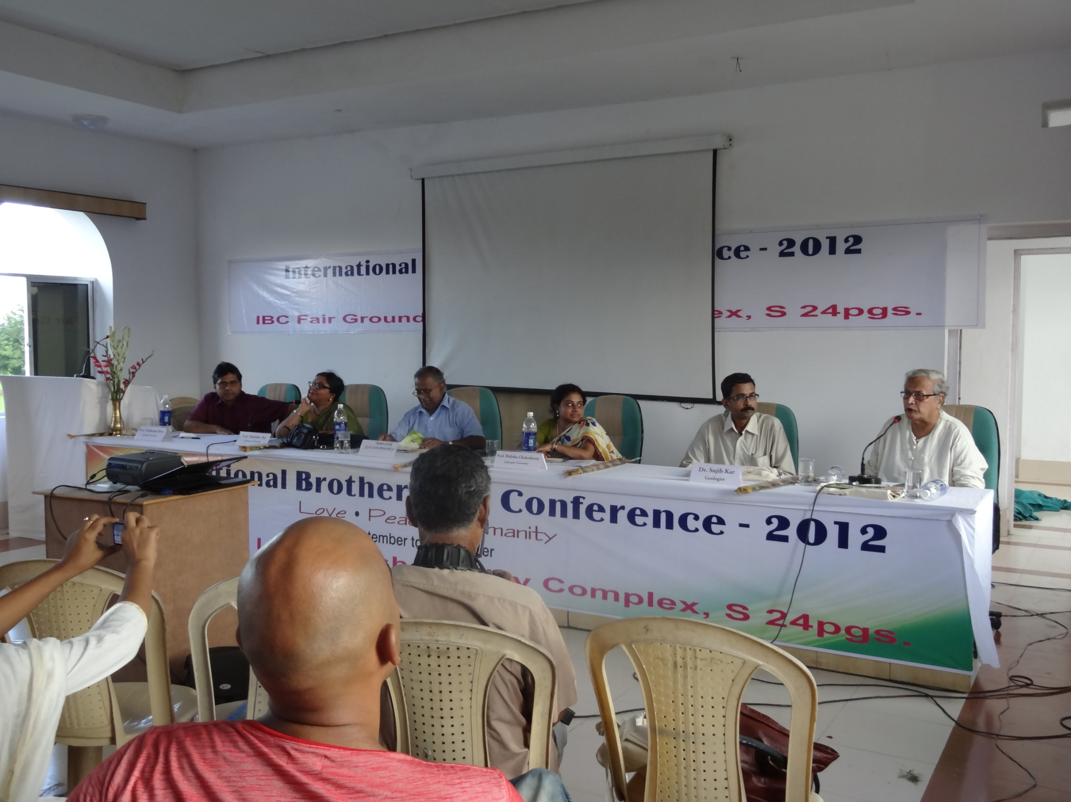
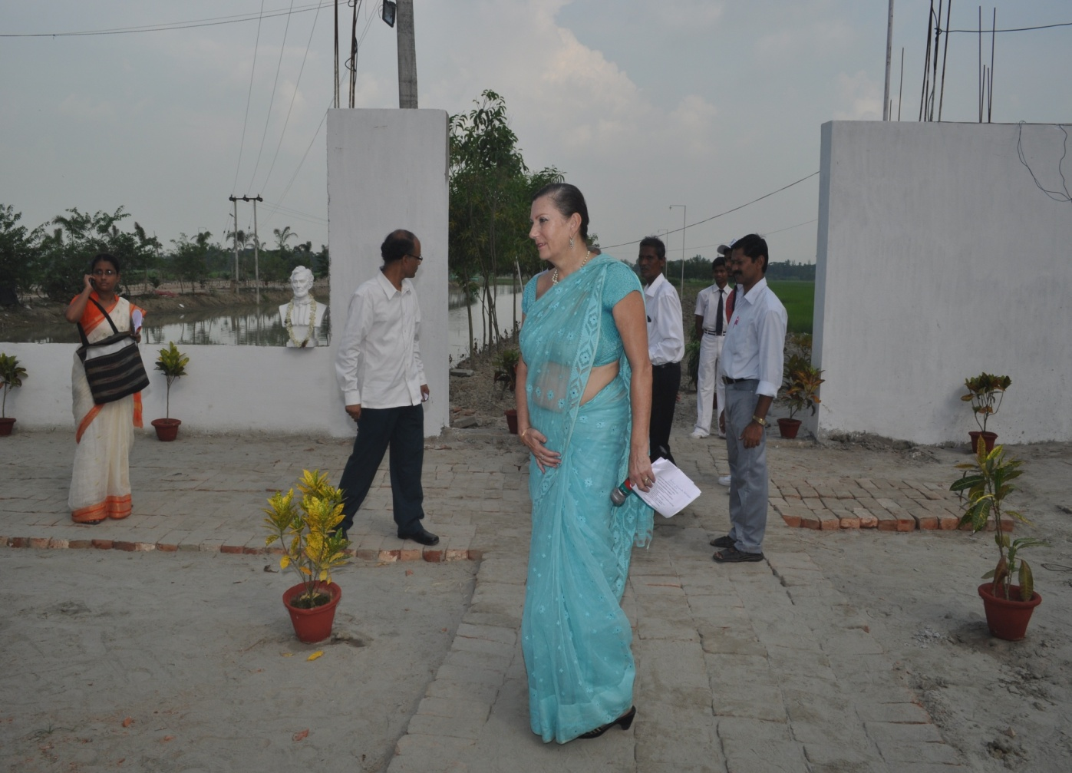
Prof. Siddhartha Mitra
Prof. Ranjit Goswami
Andrea Loseries
Suresh Datta

Prof. Malabika Roy
Prof. Bidisha
Chakraborty
Mr. H.R.Sur
Mr. Pujan Ghosh

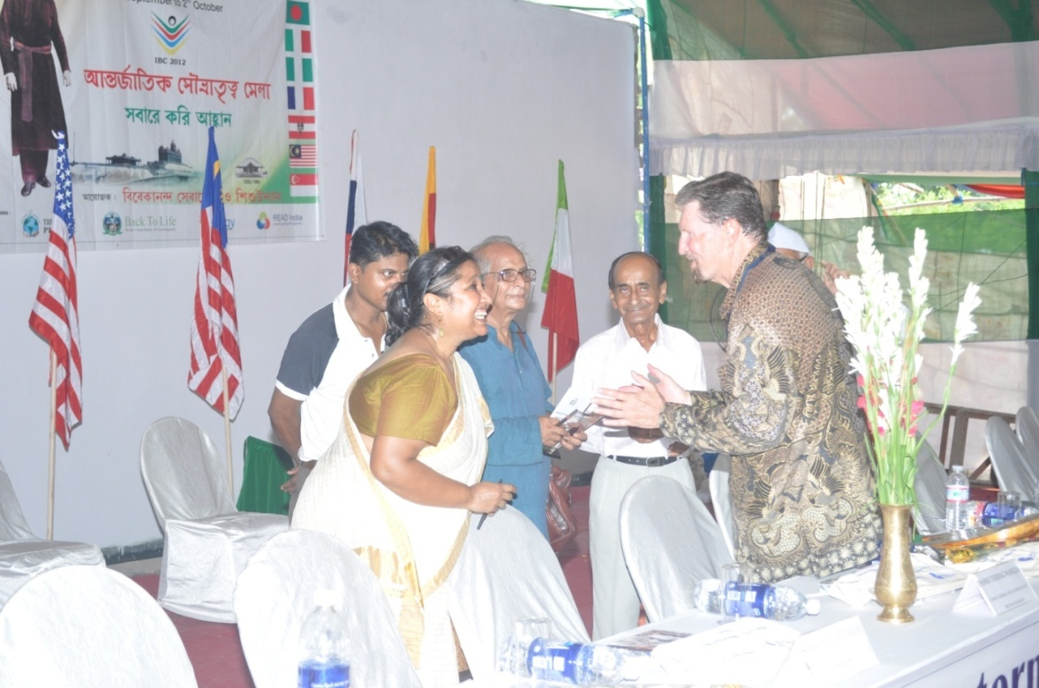
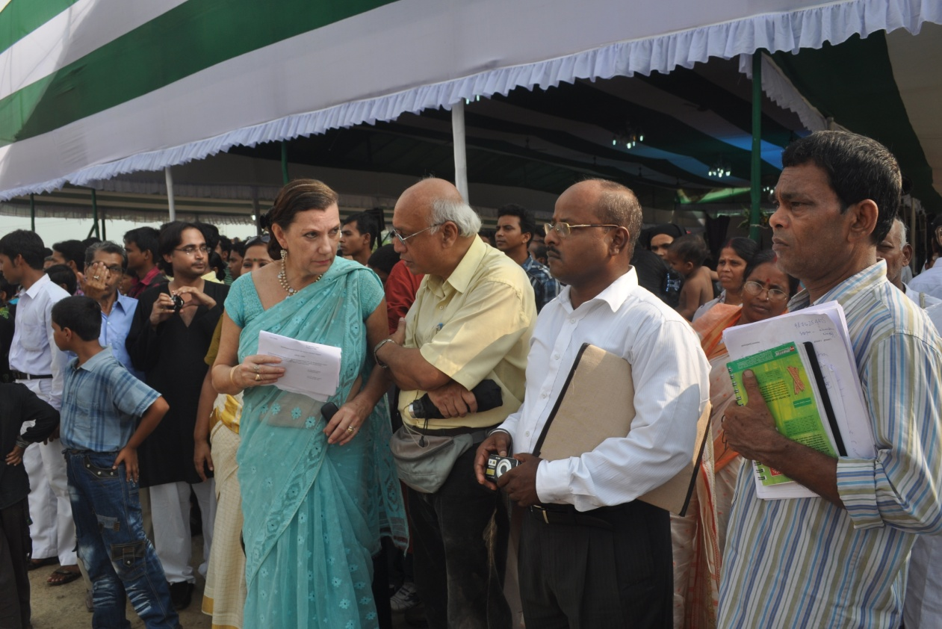
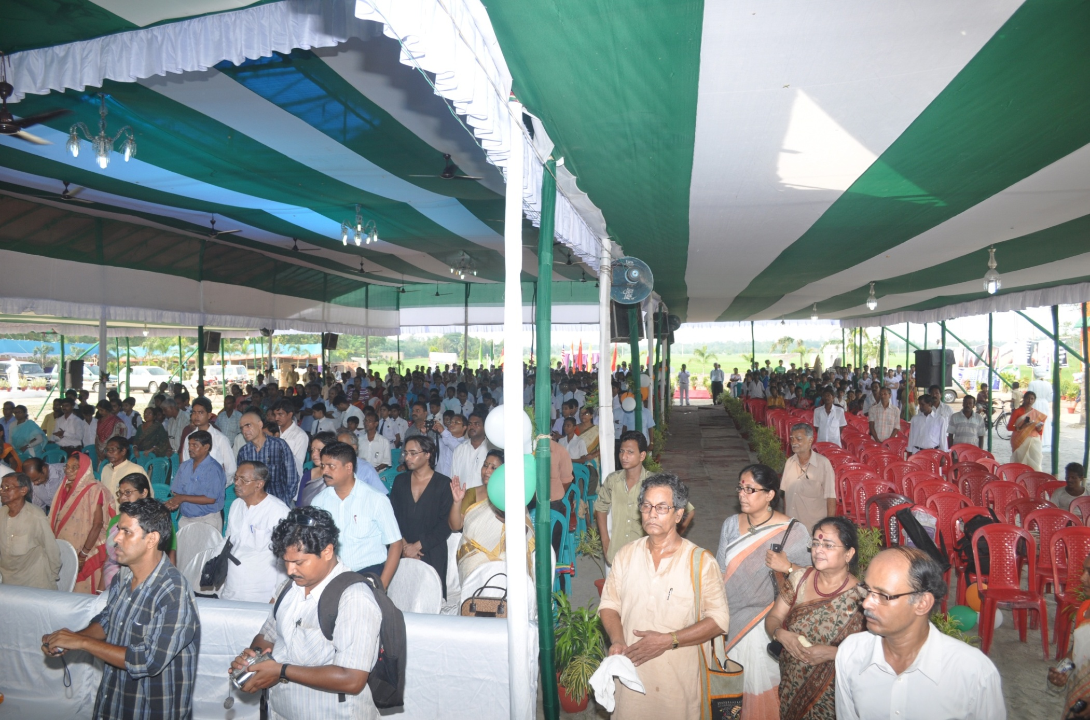
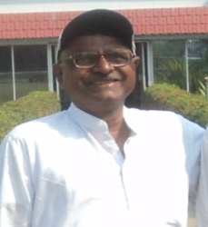

Mrs. Debasmita Moulick
Dr. Subhrankar Mukherjee
Ms. Ratna Mitra
Mr. D K Mustafi

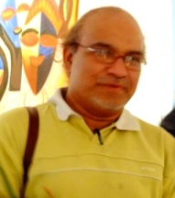
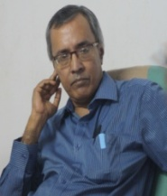
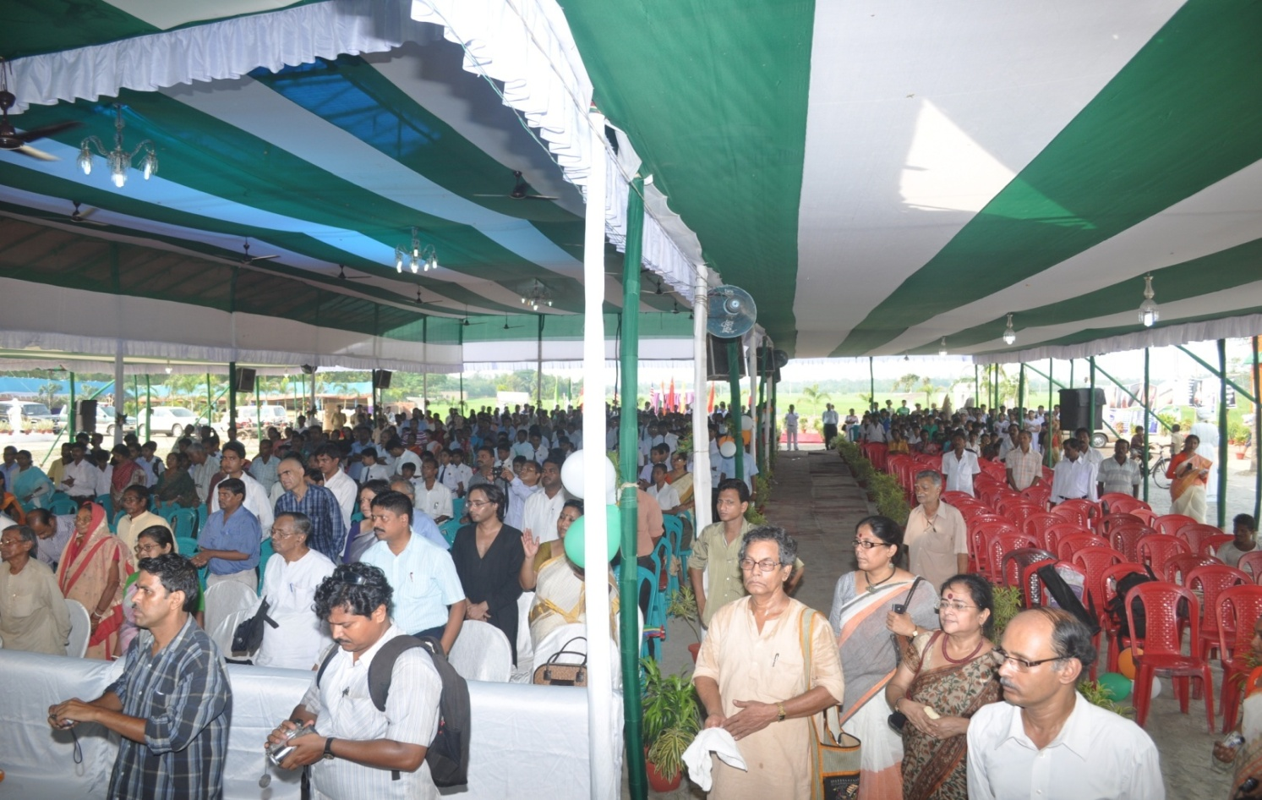
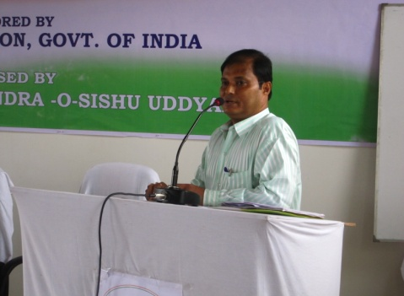
Prof Govt Collg of Art & Craft
Mr. Subendu Bhattacharaya
Prof. Amit Sengupta
Mr. Pratul Das
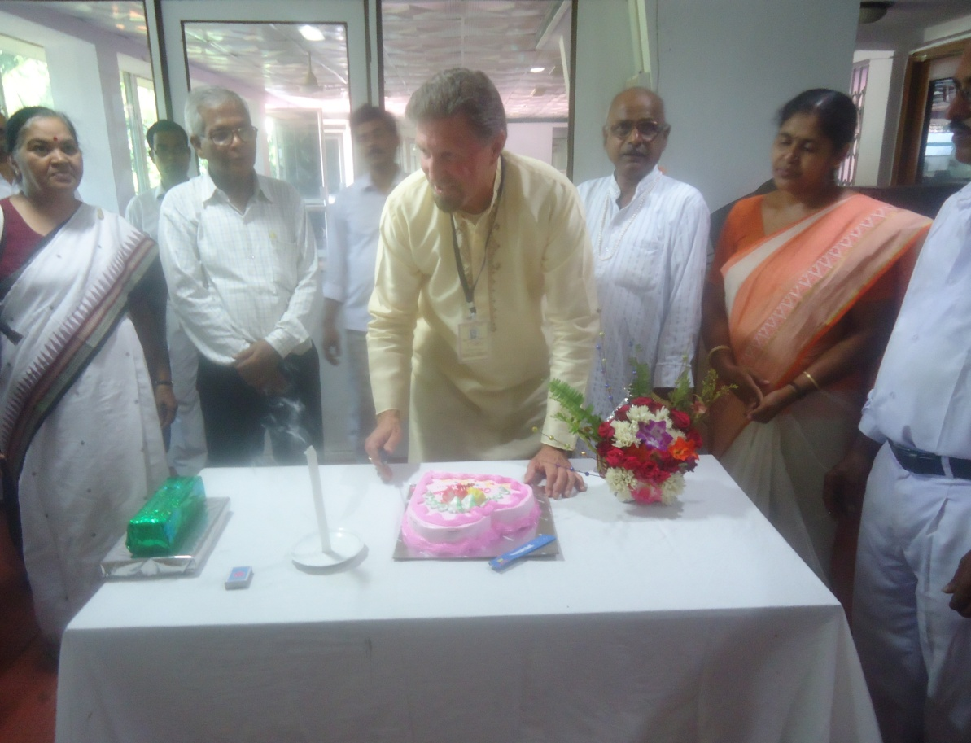
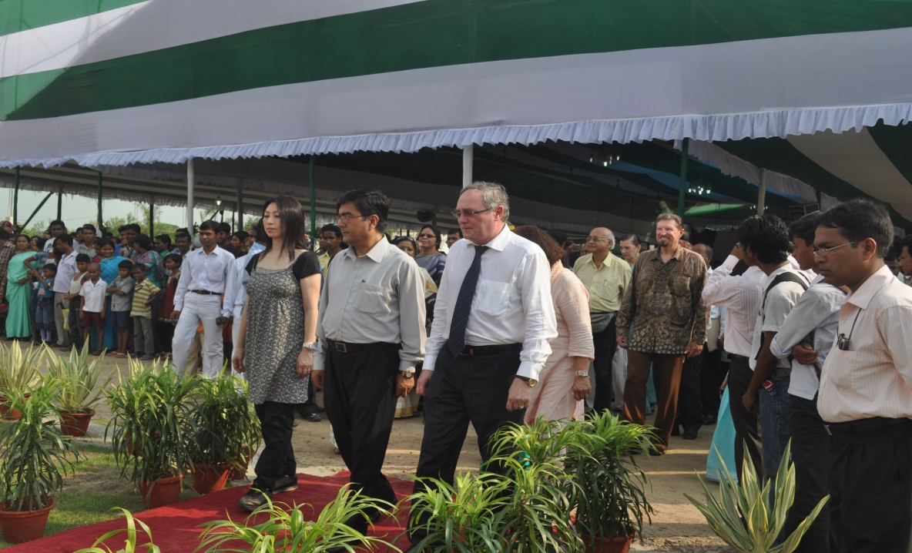
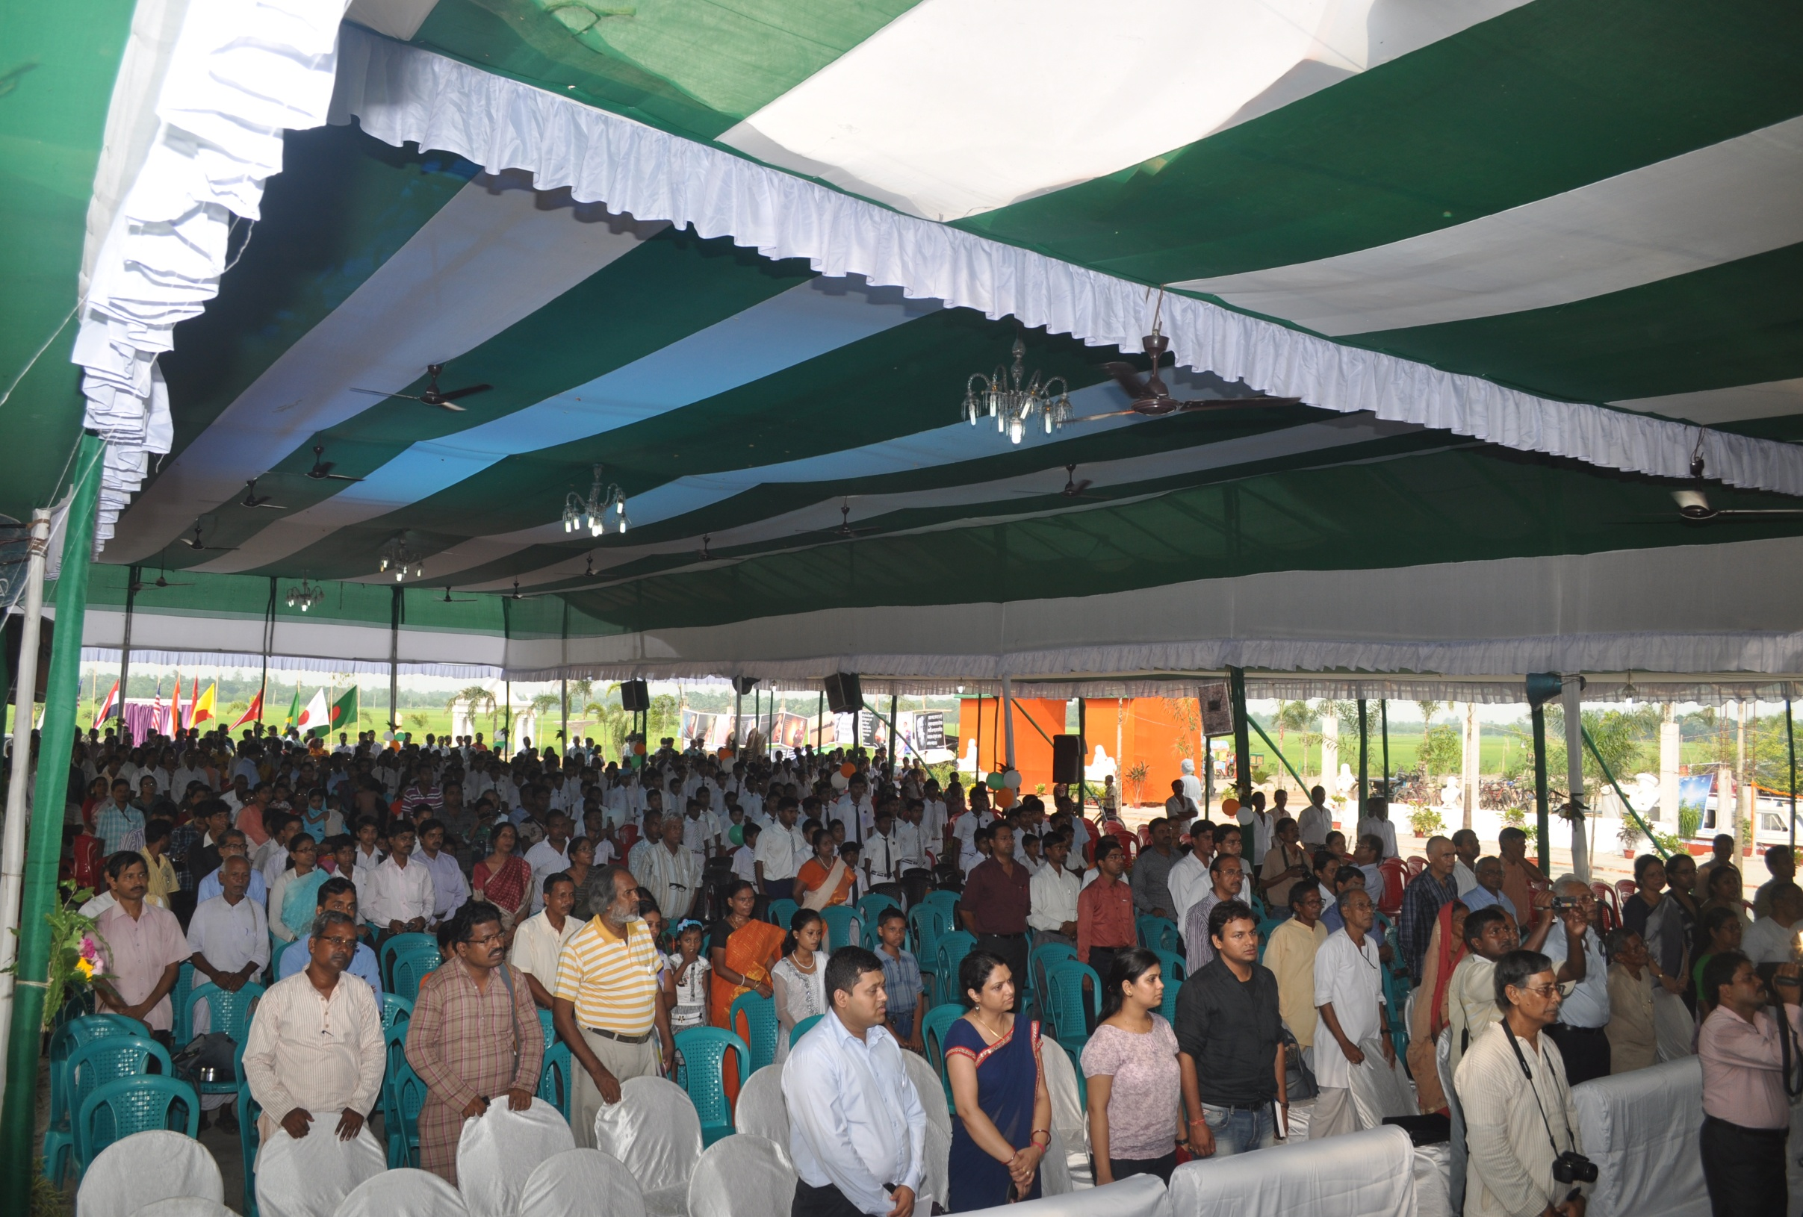
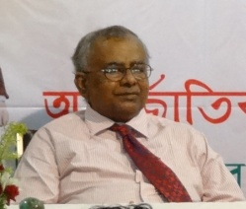

Prof. Asha Mukherjee
Mr.Ashutosh Kumar
Mr. Nazibul Islam
Mr. S.P.Chakraborty

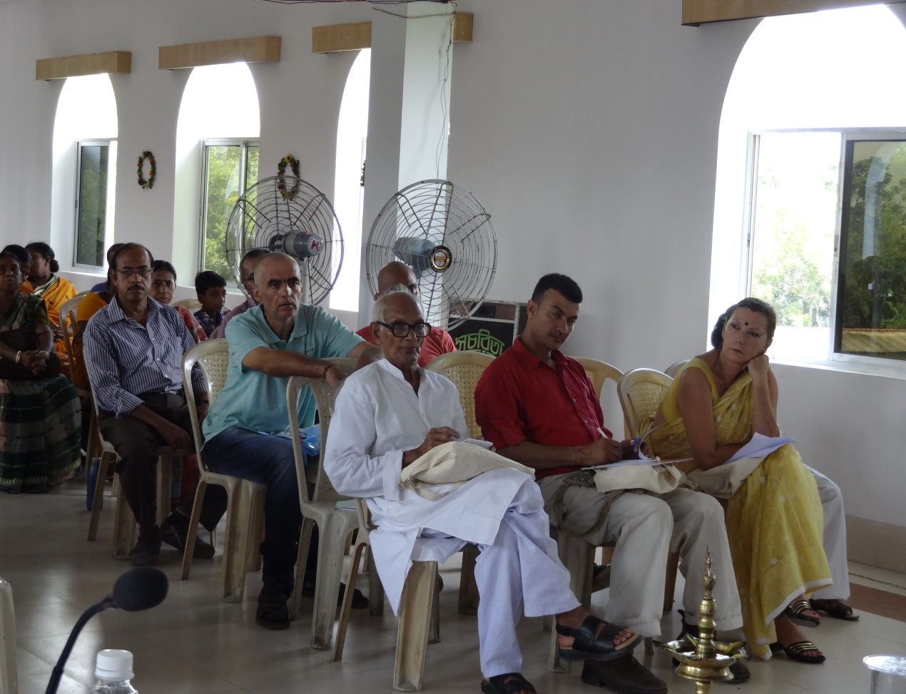
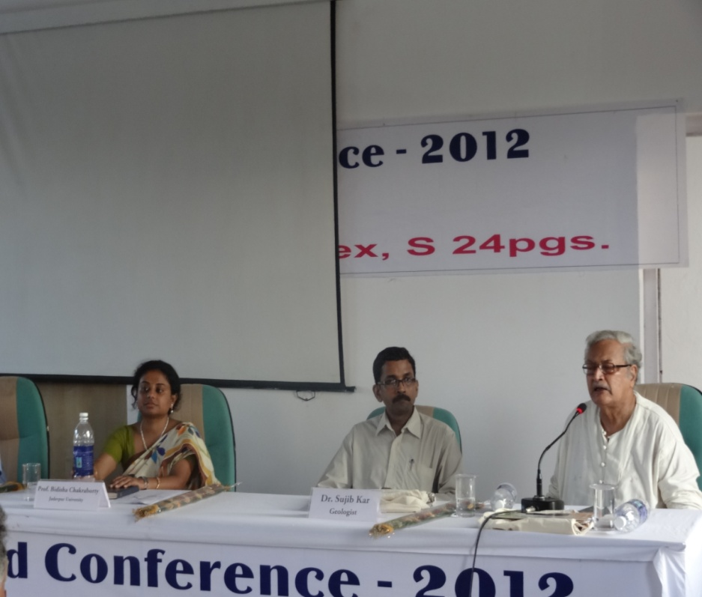
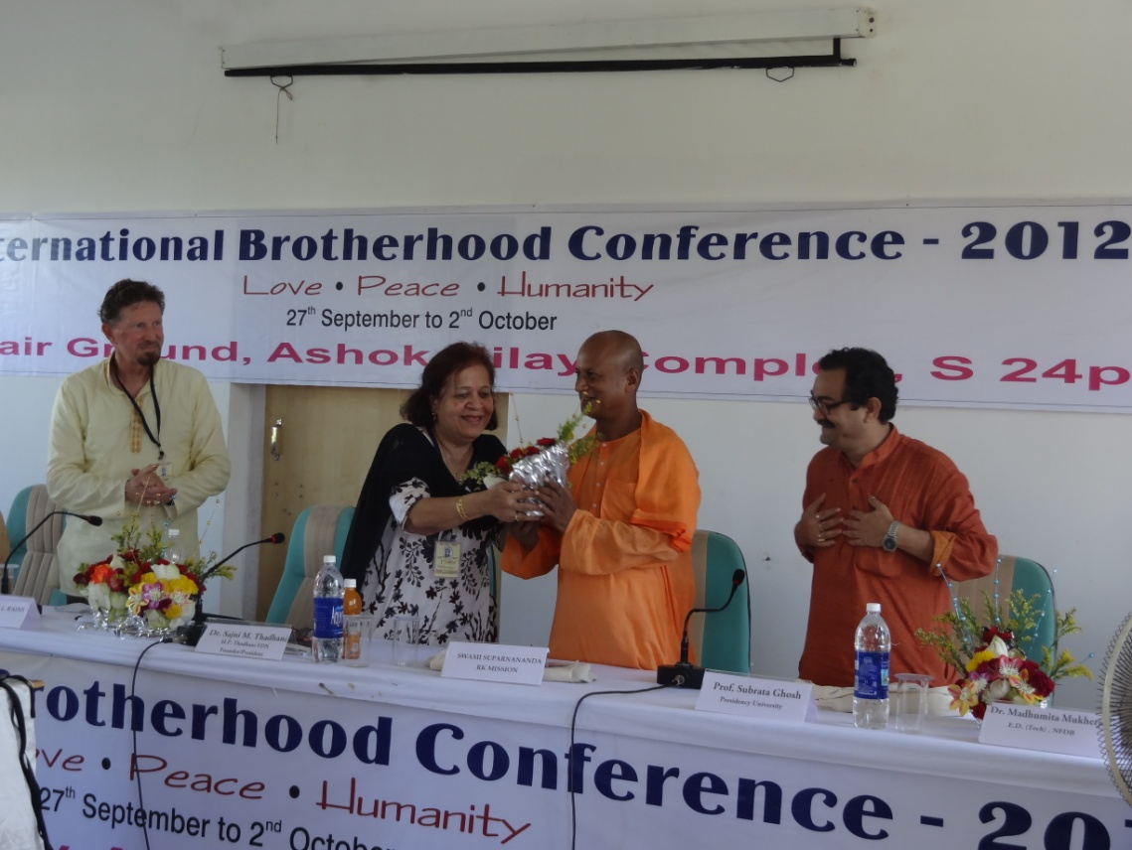
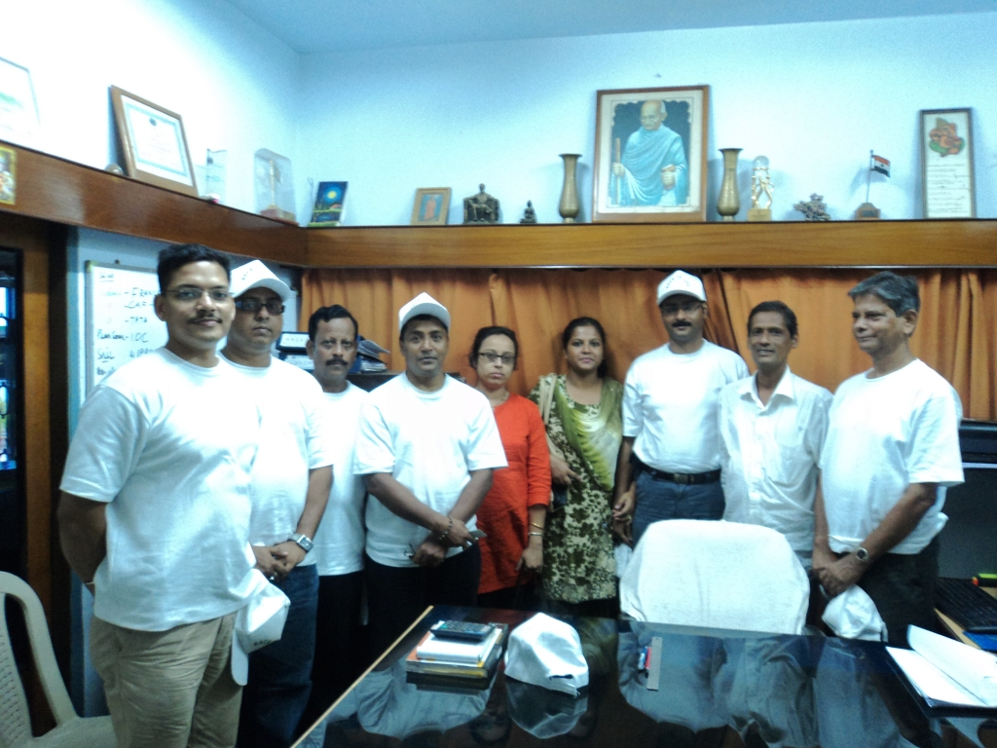

Carlos

Dr. Sujib Kar

Prof. Subrata Ghosh

Mr. Dripta Sarkar

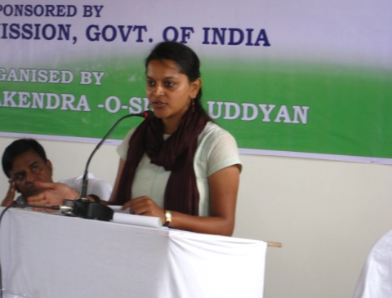
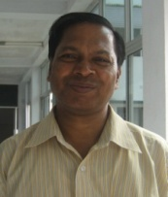
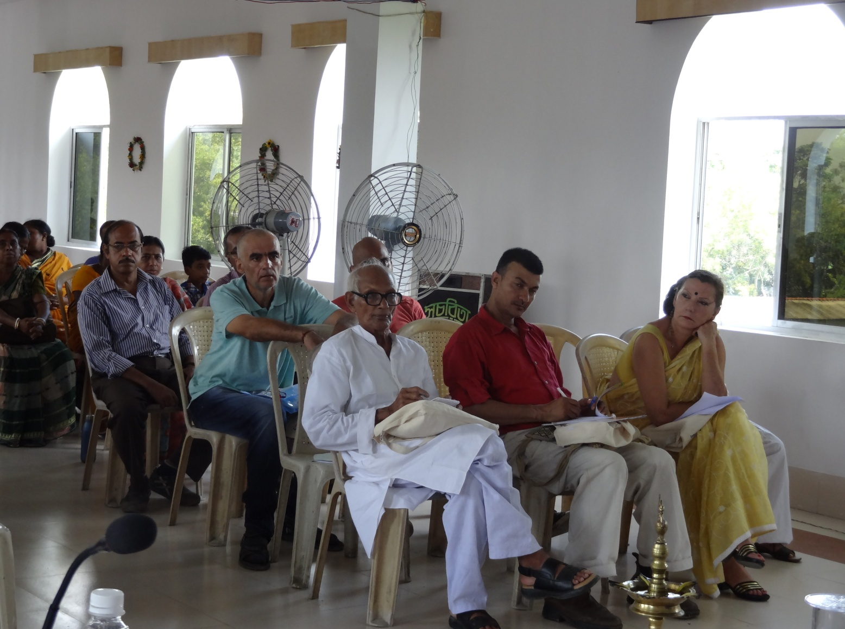
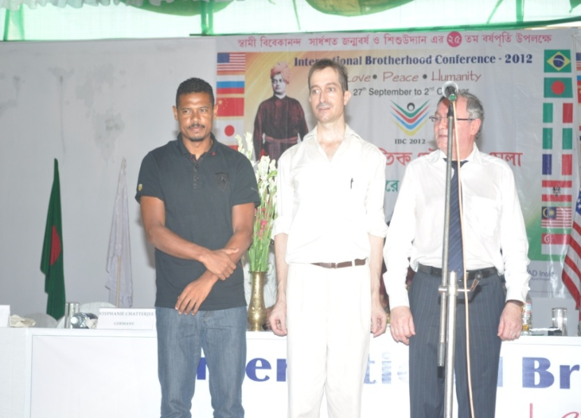
Mrs. Ekta Kothari
Mr. Sanjit Purkait

Mr. Salil Sarkar

Jose Ramirez Barreto

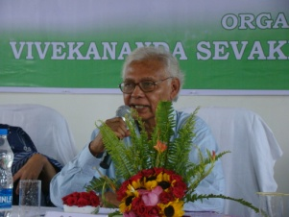
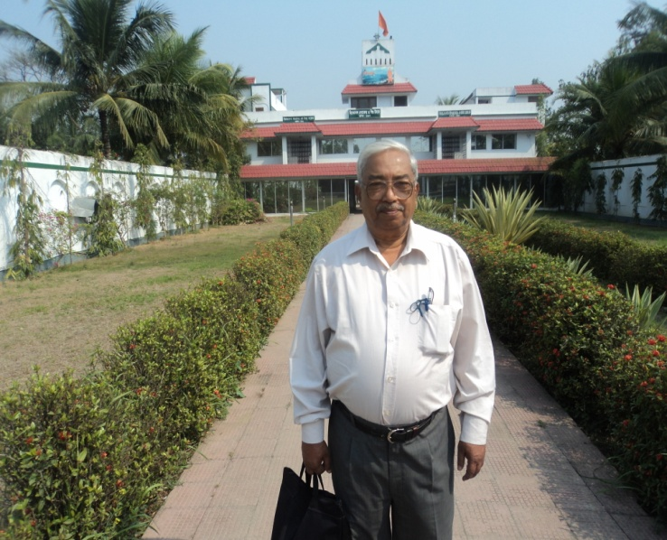
Mr. S.R.Basu
Mr. S.B.Mondal

Acknowledgement
Vivekananda Sevakendra-O-Sishu Uddyan humbly acknowledge the support of:

Citizens of South 24 Parganas, VSSU Microfinance Clients, Well-wishers, Laborers, Contractors, Decorators, Sound System Providers, Land Donors and associated others.

Local Administration – Gabberia & Ghateswar Gram Panchayat, Block Development Officer, Mandir Bazar Block, Agriculture Development Officer, Mandir Bazar Block, Officer-in-Charge, Mandir Bazar Police Station, South 24 Parganas.

Swami Suparnananda Maharaj, Secretary,Narendrapur Ramkrishna Mission
Supriya Tagore,Educationist, Santiniketan

Sub-Divisional Police Officer, Diamond Harbour, South 24 Parganas
District Magistrate, South 24 Parganas
Ministry of External Affairs, Govt.of India
Ministry of Home Affairs, Govt.of India
Ministry of Culture, Govt.of India
Ministry of Commerce and Industry, Govt.of India
Department of Economic affairs, Ministry of Finance, Govt.of India
Reserve Bank of India

CONSULATE GENERALS, VICE-CONSULS, FOREIGN DELEGATES FROM 14 COUNTRIES, 4 CONTINENTS

Mr. Rameshwor Paudel, Consul General of Nepal
Mr. Alexander V. Mazirika, Vice-Consul & Director of the Russian Centre of Science & Culture in Kolkata
José Ramirez Barreto, Brazil, Football Player of Mohan Bagan
Laurent Fournier, Architect, France
Li Jie, Cultural Attaché, China
Andrea Loseries, Austrian Cultural and Social Anthropologist
Rahul K. Agarwal, Social Entreprise, Malaysia
Dr. Sajni Thadhani, MFTP Founder & President, USA
Jorn Duwel, Michiel Tramper, Sjoerd Vonk Delft University of Technology, The Netherlands
Naomi Isemura, Representative of Japan
Mr. Bishop, Nigeria
Bangladesh Sangeet Bhavan
Eastern Zonal Cultural Centre

SPECIAL THANKS TO:

Hon’ble Senator Omer L. Rains, USA
The Prime Minister of the United Kingdom
Department of Prime Minister & Cabinet, Australian Government,
Dasho Thrsering Wangda, Consul General, Royal Bhutanese Consulate, Kolkata
Ratan Tata, Chairman Emeritus, TATA Group of Industries
Ministry of Finance, Govt. of India

SPONSOR ORGANISATIONS

Back to Life
READ India, Delhi
ONergy & Boston Pledge

INDIVIDUAL THANKS TO:

Poojan Ghosh for cultural contacts
Debasmita Moulick, VSSU Foreign Liaison Officer
S.P. Chakraborty
Salil Sarkar
Tamal Halder, Biplab das , Banani Mandal
Chetan Sevasram Sangha
Executive Committee Members VSSU
All the staffs of VSSU
And The Oceanic Library

Thank you!!!

